REPLY TO ATTENTION OF:

Regulatory Branch
DEPARTMENT OF THE ARMY
NEW YORK DISTRICT, CORPS OF ENGINEERS JACOB K. JAVITS FEDERAL BUILDING
NEW YORK, N.Y. 10278-0090
April 12, 2021

SUBJECT: Request for Permit Modification of Department of the Army Permit Number NAN-2017-01454-M1 by New Jersey Department of Transportation, Route 1& 9T New Road Project, City of Jersey City and Town of Secaucus, Hudson County, New Jersey

PERMITTEE:

New Jersey Department of Transportation c/o Ms. Amber Cheney
Division of Capital Program Support
Bureau of Landscape Architecture and Environmental Solutions 1035 Parkway Avenue
Trenton, New Jersey 08625

- Reference is made to:

  - Subject Department of the Army (DA) permit issued 10, April 2018; and,

  - The subject permittee’s requested, via email correspondence dated 5 March 2021, that the Corps extend the expiration date of DA Permit No. NAN-2017-01454 through 5 February 2023 to complete the previously authorized activities.

- Based upon an evaluation of the administrative record supporting the issuance of the subject permit, and a review of the permittee’s submitted materials in support of their permit extension request, current New Jersey Department of Environmental Protection (NJDEP) Flood Hazard Area Individual Permit 0906-15-0010.1 FHA170001 and HMC Water Quality Certificate 0906-15-0010.1 CDT170001, expiration date 5 February 2023; this office has determined that such an extension would not be contrary to the public interest.

- The subject permit is hereby specifically modified to extend the expiration date to 5 February 2023.

- The modification of this permit shall be known as Department of the Army Number NAN- 2017-01454-M1. All other terms, General Conditions, and Special Conditions of the subject issued permit shall remain in effect. This modified subject DA permit shall be available at project offices and regulated work sites.

SUBJECT: Request for Permit Modification of Department of the Army Permit Number NAN-2017-01454-M1 by New Jersey Department of Transportation, Route 1& 9T New Road Project, City of Jersey City and Town of Secaucus, Hudson County, New Jersey

- If you have any questions regarding this matter please contact Ms. Danielle Courtois, Project Manager, Western Section, at 347-439-9343.

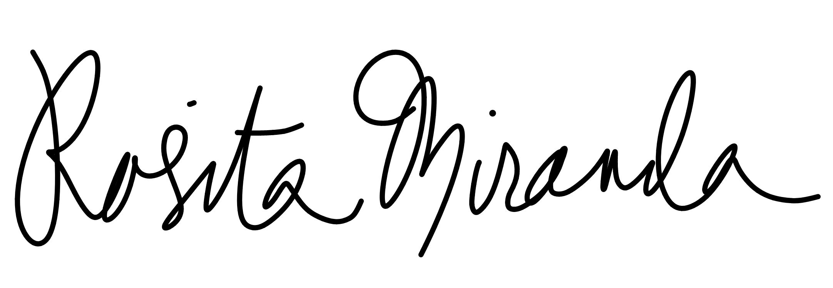
Date: 2021.04.12
13:56:02 -04'00'
FOR AND IN BEHALF OF
Matthew W. Luzzatto
Colonel, U.S. Army Commander

Enclosure
- NJDEP Permit dated February 5, 2018
- DA permit dated April 10, 2018

CF: (with encl) CENAN-OP-R NYSDEP NJSEA

Permittee:
DEPARTMENT OF THE ARMY PERMIT
New Jersey Department of Transportation 1035 Parkway Avenue
Trenton, New Jersey 08625 (906) 530-3385

Permit Number: Date Issued: Issuing Office:
NAN-2017-01454
APR 1 0 2018

U.S. Army Corps of Engineers, New York District

NOTE: The term "you" and its derivatives, as used in this permit, means the permittee or any future transferee. The term "this office" refers to the appropriate district or division office of the Corps of Engineers having jurisdiction over the permitted activity or the appropriate official of that office acting under the authority of the commanding officer.

You are authorized to perform work in accordance with the terms and conditions specified below.

Project Description:

The regulated activities authorized by this Department of the Army Permit for the 2-mile Route 1 & 9T New Road project include the discharge of approximately 5,900 cubic yards of fill material into 2.202 acres of waters of the United States to facilitate the construction and installation of the following:

- Two 12-foot wide lanes (one in each direction), each with a 15-foot wide outside shoulder,
and a 10-foot wide earthen berm extending along each side of the new road (1.095 impact acres);
- Four new bridge structures (0.095 impact acres):
  - Structure 1 - New Jersey Transit Main Rail Line (87 linear feet);
  - Structure 2 - New Jersey Transit Wye Track (157 linear feet);
  - Structure 3 - New road viaduct of the existing New Jersey Transit Main Rail Line and Norfolk Southern Croxton Yard (2,419 linear feet); and
  - Structure 4 - A new single span (prestressed concrete slab bridge over an existing drainage ditch by Secaucus road (32 linear feet);
- Eight retaining walls ranging from 560 to 4,315 linear feet in length (0.074 impact acres);
- A new outfall structure (0.0001 impact acres);
- The widening of County Road (0.163 impact acres);
- The filling of approximately 4,400 linear feet of an existing open unnamed drainage ditch (0.522 impact acres) situated along the U.S. Postal Service Bulk Mail Facility;
- The relocation of approximately 560 linear feet of the open unnamed drainage ditch (0.055 impact acres) situated along the U.S. Postal Service Bulk Mail Facility; and
- The reconfiguration of Secaucus Avenue (0.198 impact acres).

ENG FORM 1721, Nov 86 EDITION OF SEP 82 IS OBSOLETE. (33 CFR. 325 (AppemlixA))

1145-2-303b(New Jersey Department of Transportation /Penhorn Creek, Hackensack River Watershed/Discharge fill into waters of the U.S. to facilitate the construction and installation of the Route 1 & 9T New Road)

A total of approximately 2.63 acres of waters of the United States shall be temporarily disturbed as part of the proposed new road construction activities. Upon completion of the road instalJation acfivities, all temporarily disturbed waters of the United States, including wetlands, shall be restored to preconstruction conditions and planted with native hydrophytic vegetation where appropriate.

All work shall be performed in accordance with the attached drawings and special conditions (A) through (H) which are hereby made part of this permit, and the New Jersey Department of EnvironmentaJ Protection Permit No. 0906-15-0010.1, COT 170001, 0906-15-0010.1 FHA 170001, incorporating the Section 401 Water Quality Certificate, which are hereby made a part of this permit.

Project Location: IN: Penhorn Creek (Hackensack River Watershed)

AT: City of Jersey City and Town of Secaucus, Hudson County, NJ

Permit Conditions:

General Conditions:

- The time limit for completing the work authorized ends on
- - - - - A_PR_ 1_01__20_2_1 . If you find that you need more time to complete the
authorized activity, submit your request for a time extension to this office for consideration at least one month before the above date is reached.

- You must maintain the activity authorized by this permit in good condition and in conformance with the terms and conditions of this permit. You are not relieved of this requirement if you abandon the permitted activity, although you may make a good faith transfer to a third party in compliance with General Condition 4 below. Should you wish to cease to maintain the authorized activity or should you desire to abandon it without a good faith transfer, you must obtain a modification of this permit from this office, which may require restoration of the area.

- If you discover any previously unknown historic or archeological remains while accomplishing the activity authorized by this permit, you must immediately notify this office of what you have found. We will initiate the Federal and state coordination required to determine if the remains warrant a recovery effort or if the site is eligible for listing in the National Register of Historic Places.

- If you sell the property associated with this permit, you must obtain the signature of the new owner in the space provided and forward a copy of the permit to this office to validate the transfer of this authorization.

- If a conditioned water quality certification has been issued for your project, you must comply with the conditions specified in the certification as special conditions to this permit. For your convenience, a copy of the certification is attached if it contains such conditions.

ENG FORM 1721, Nov 86 EDITION OF SEP 82 IS OBSOLETE. (JJ CFR 325 (Appendix A)}

2

- You must allow representatives from this office to inspect the authorized activity at any time deemed necessary to ensure that it is being or has been accomplished in accordance with the terms and conditions of your permit

Special Conditions:

(A) Prior to commencing any work in waters of the United States authorized by this permit, the permittee shall provide the New York District Corps of Engineers with written verification that a total of 2.5 wetland mitigation credits have been purchased from a federally approved wetland mitigation bank within the Hackensack Meadowlands to compensate for the 2.202 acres of permanent unavoidable impacts to waters of the United States associated with the "Route 1 & 9T New Road" project. This verification document shall be submitted to the following address:

Chief, Regulatory Branch
New York District, U.S. Army Corps of Engineers Jacob K. Javits Federal Building
26 Federal Plaza, 19th Floor
New York, New York 10278-0090

(B} The permittee understands and agrees that, iffuture operations by the United St.ate-s require the removal, relocation, or other alteration, of the structure or work herein authorized, or if, in the opinion of the Secretary of the Army or his authorized representative, said structure or work shall cause unreasonable obstruction to the free navigation of the navigable waters, the permittee will be required, upon due notice from the U.S. Army Corps of Engineers, to remove, relocate, or alter the structural work or obstructions caused thereby, without expense to the United States. No claim shall be made against the United States on account of any such removal or alteration.

- The permittees and their designated contractors shall be responsible for, and shall comply with, all of the conditions and stipulations contained .within the attached New Jersey Department of Environmental Protection Water Quality Certification dated February 6, 2018 (Permit No. 0906 15-0010.1, CDT 170001, 0906-15-0010.1 FHA 170001), and all amendments, thereto.

- The permittee and their contractors shall ensure that no work or disturbance occurs to the existing and federally approved Norfolk Southern Railway Company wetland mitigation site known as the "Croxton Wye Wetland Mitigation" site situated along the Norfolk Southern Railway Company Wye Track. A copy of the "Croxton Wye Wetland Mitigation" site Conservation Easement and associated drawings of the mitigation site is attached.

- A complete copy of this permit, including its drawings, special conditions and any amendments shall be maintained at the work site whenever work is being performed. The permittee shall assure that all contractors, subcontractors and other personnel performing the permitted work are fully aware of the permit's terms and conditions.

ENG FORM 1721, Nov 86 EDITION OF SEP 82 IS OBSOLETE. (33 CFR 325 (Appendix A))

3

- The permittee shall undertake the authorized activities in a manner aimed at reducing impacts upon the general environment. In addition, the permittee shall not stockpile fill or other materials in a manner conducive to erosion, or in areas likely to cause high turbidity runoff during storm events. The permittee shall use all practicable measures during construction {e.g.
silt fences, hay bales, erosion control netting, vegetative stabilization) to stabilize all exposed soils immediately upon the completion of each phase of the grading activities in all areas, and appropriate temporary fencing shall be installed around all on-site wetlands and waters of the United States not authorized herein to be impacted and other sensitive ecological areas during construction periods, to prevent equipment and personnel from entering these areas.

- The permittee shall restore all temporarily disturbed wetlands and waters of the United States to preconstruction conditions and plant the areas with native hydrophytic vegetation where appropriate.

- The permittee shall respond to all reasonable requests for information from the New York District Corps of Engineers, and provide necessary field support during field investigations and permit compliance inspections. Any representative of the Corps of Engineers shall be granted authorization to access the site for the purpose of site inspections.

Further Information:

- Congressional Authorities: You have been authorized to undertake the activity described above pursuant to:

(X) Section 10 of the Rivers and Harbors Act of 1899 (33 U.S. Code 403).

(X) Section 404 of the Clean Water Act (33 U.S. Code 1344).

() Section 103 of the Marine Protection, Research and Sanctuaries Act of 1972 (33 U.S.C.1413).

- Limits of this authorization:

  - This permit does not obviate the need to obtain other Federal, state, or local authorizations required by law.

  - l;"his permit does not grant any property rights or exclusive privileges.

  - This permit does not authorize any injury to the property or rights of others.

  - This permit does not authorize interference with any existing or proposed Federal project.

- Limits of Federal Liability: In issuing this permit, the Federal Government does not assume any liability for the following:

ENG FORM 1721, Nov 86 EDITION OF SEP 82 IS OBSOLETE. (33 CFR 325 (Appendix A))

4

  - Damages to the permitted project or uses thereof as a result of other permitted or unpermitted activities or from natural causes.

  - Damages to the permitted project or uses thereof as a result of current or future activities undertaken by or on behalf of the United States in the public interest.

  - Damages to persons, property, or to other permitted or unpermitted activities or structures caused by the activity authorized by this permit.

  - Design or construction deficiencies associated with the permitted work.

  - Damage claims associated with any future modification, suspension, or revocation of this permit.

- Reliance on Applicant's Data: The determination of this office that issuance of this permit is not contrary to the public interest was made in reliance on the information you provided.

- Reevaluation of Permit Decision: This office may reevaluate its decision on this permit at any time the circumstances warrant. Circumstances that could require a reevaluation include, but are not limited to, the following:

  - You fail to comply with the terms and conditions of this permit.

  - The information provided by you in support of your permit application proves to have been false, incomplete, or inaccurate (See 4 above).

  - Significant new information surfaces which this office did not consider in reaching the original public interest decision.

Such a reevaluation may result in a determination that it is appropriate to use the suspension, modification, and revocation procedures contained in 33 CFR 325.7 or enforcement procedures such as those contained in 33 CFR 326.4 and 326.5. The referenced enforcement procedures provide for the issuance of an administrative order requiring you to comply with the terms and conditions of your permit and for the initiation of legal action where appropriate. You will be required to pay for any corrective measures ordered by this office, and if you fail to comply with such directive, this office may in certain situations {such as those specified in 33 CFR 209.170) accomplish the corrective measures by contract or otherwise and bill you for the cost.

- Extensions: General Condition 1 establishes a time limit for the completion of the activity authorized by this permit. Unless there are circumstances requiring either a prompt completion of the authorized activity or a reevaluation of the public interest decision, the Corps will normally give favorable consideration to a request for an extension of this time limit.

ENG FORM 1721, Nov 86 EDITION OF SEP a2 IS OBSOLETE (33 CFR 325 (Appendix.A.))

5

Your signature below, as permittee, indicates that you accept and agree to comply with the terms and conditions of this permit.

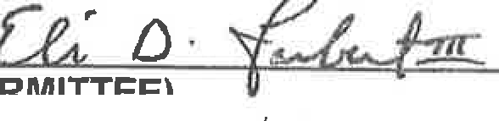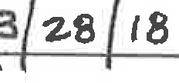(_,," D' L/-hW/3[5}2,'7EC.-

(PERMITTEE)

(DATE)
New,l(liltMdf nibneff.r !1sportation
@Bpl program Managemeffl

This permit becomes effective when the Federal official, designated to act for the Secretary of the Army, has signed below. ·

For andIn a alf of
Thomas D. Asbery Colonel, U.S. Army District Engineer

(DATE)
APR 1 0 2018

When the structures or work authorized by this permit are still inexistence at the time the property is transferred, the terms arid conditions of this permit will continue to be binding on the new owner(s) of the property. To validate the transfer of this permit and the associated liabilities associated with compliance with its terms and conditions, have the transferee sign and date below. A copy of the permit signed by the transferee should be sent to this office.

(TRANSFEREE) | (DATE)
ENG FORM 1721, Nov 86 | EDITION OF SEP 82 IS OBSOLETE,  6 | (33 CFR 325(Appendix A))

I
-
,... J si
I ..
I
I J l ... )
·A1 · ·.
l i
. :.., l. • f , .

,_, l.lttlto'.!ln•O
,,. , l"f!I)
- - -""'i :::- (.- • j
, • .._ I
« •
!.
. rI
tl".U..t. ..,..
:r-•·- •·•-a- -.-­
·I·••-·:- ;
n

:=:t i i :!!

Legend

FIGURE 1 - USGS Location

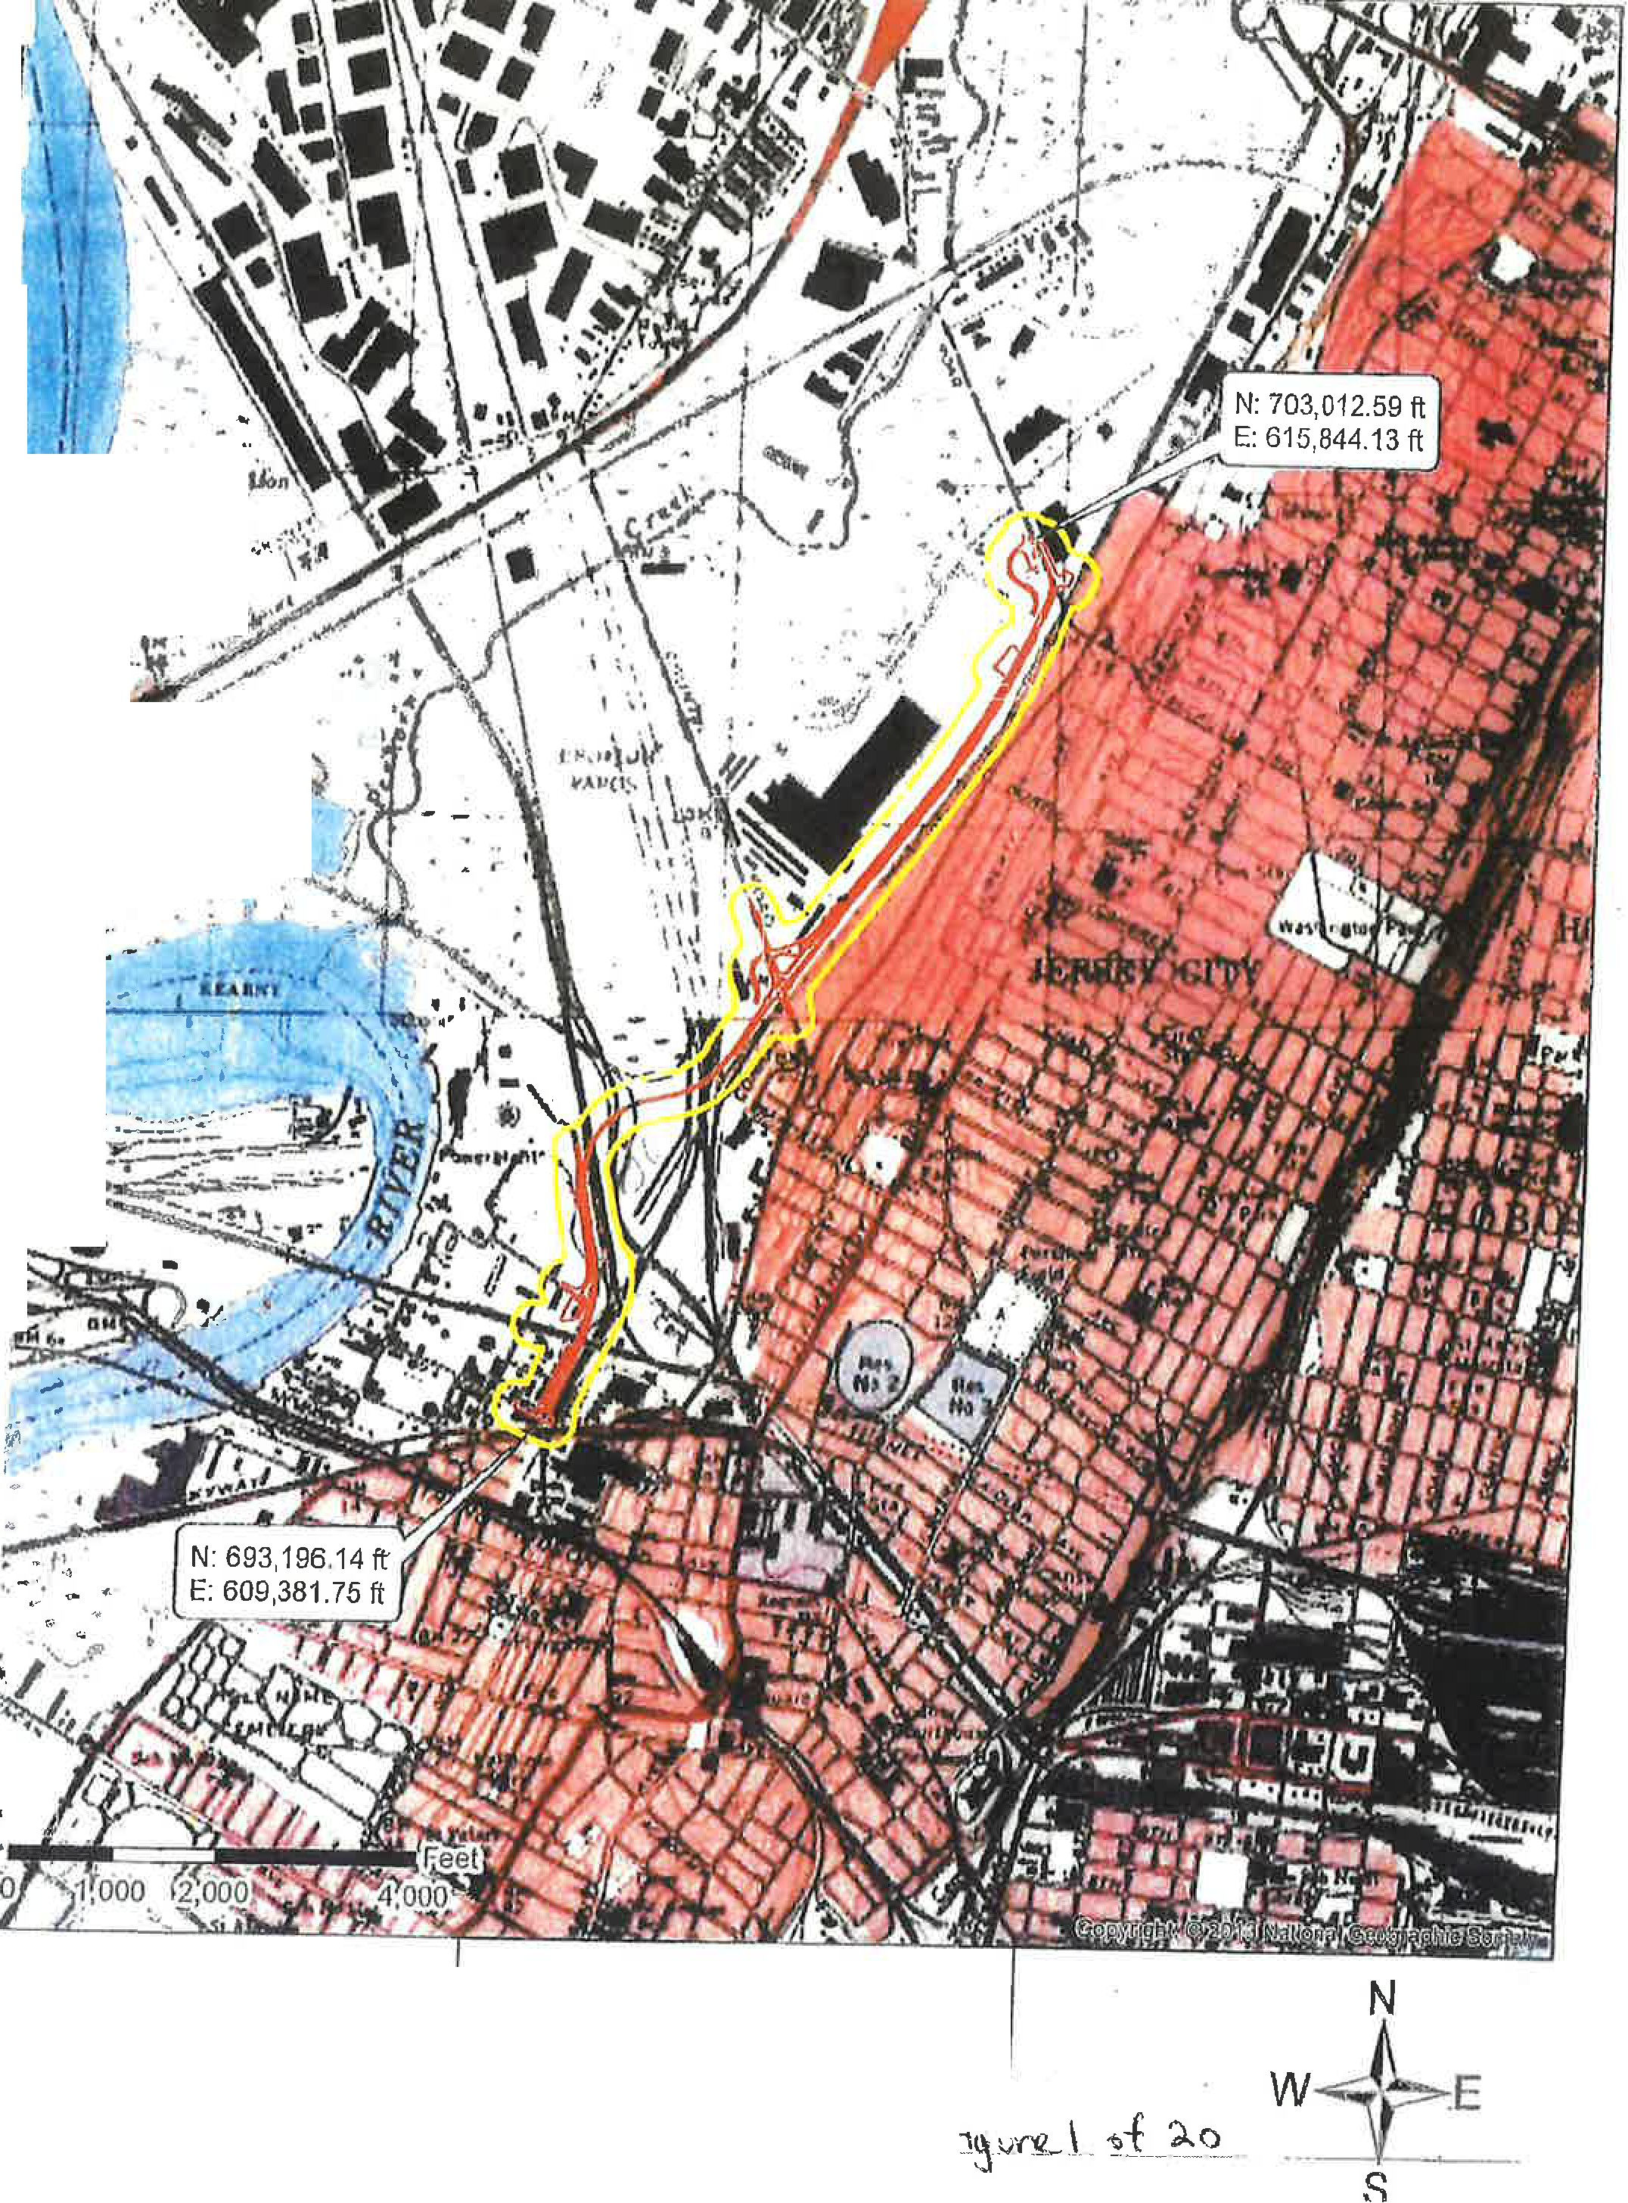
· Proposed Improvements
t --St1c1dy-Area- - ---

Legend
FIGURE 3 - Aerial Location

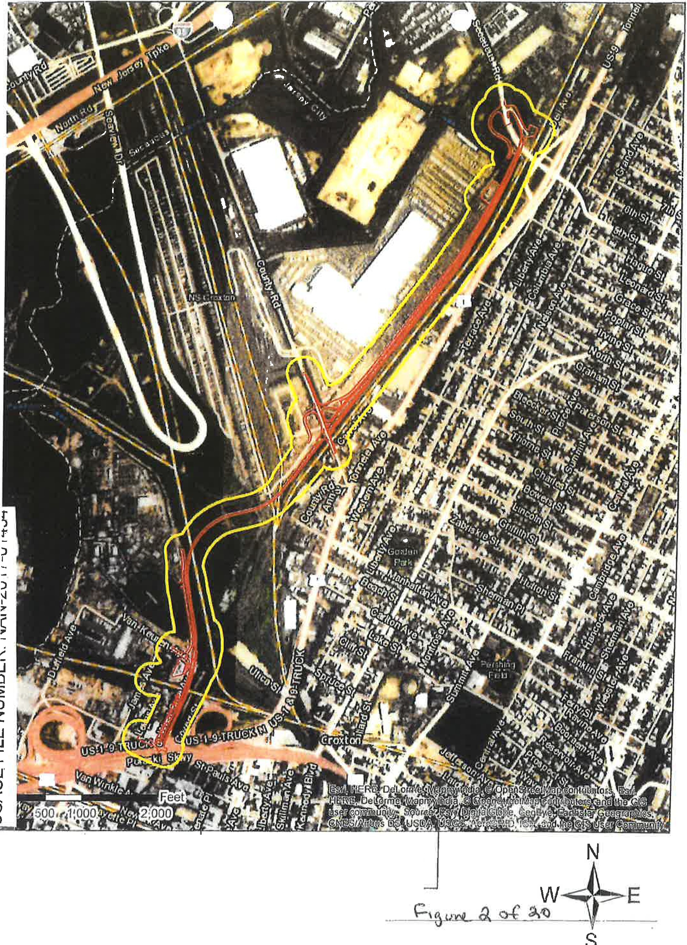
- - - Proposed Improvements
,r;:= -- - -Study-Area - - - - - --- ---

USACE FILE NUMBER: NAN-2017-01454

' \ \ .

CITY OF ,JERSEY CITY COUNTY OF HUDSON

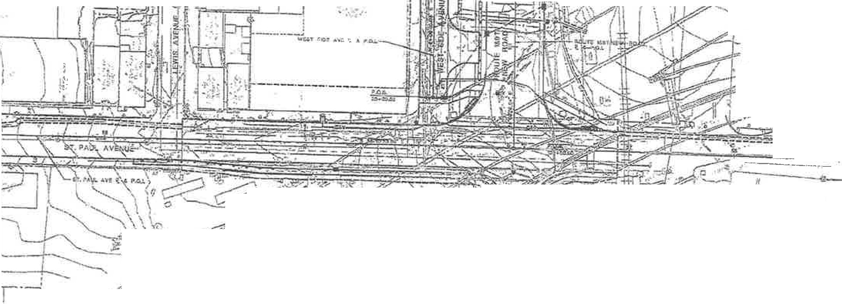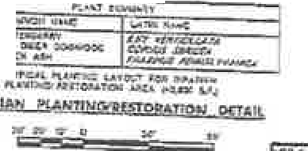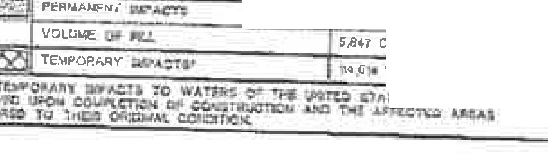fllAN JJO. AC•P-..'t .
.i::.1 ,.,..,

f¥Col IC
... .,,.
*"
d
...,.,...
,..:.i: A ..,;a,, ,,IOI(

'{..
\
'
;l -.L

' ,l
t' ,;A .. -/·

f .;.,
l . ·#- J-,
·",

: --;.;;;;..
··
.... -

. , · rp ., - - --..: • • - ,-· :.... -: .
- o:.

"" - / _ - •• •

,, · \ \ ) - 'r', .
rt
" ''\.\" 7 • \.

,

- ; 1/

· "- «-.1:}.) \ I\
- \ f'<A}
- ,-. ,

¼ 1 ---- -----. rt . \ _ .
LJ
D .......- =,...k
1 O

•-rn "

T· j1. ' ,..., . . y\

' e--. .-
t 1. - .·.
tc - ·.i

L• ,,,.,, :\

- - .d-,';\."'--1, . •-
•
- •. , ,'\
 |  |  | ,·o | "'
--- -· - | - 7 | ,..... . | ·· | (
, | /  r.."/,, | · ,  .,, | ,ll | t'!f  '1' | 1  ·' -. y··y . . II ITT | .

,;.• • \ - -
·,
I

·· _,., -· /'( <·-=•,._, r . :-.8.
! f,

-
I

"
-

""'
"'
,.

=
- - - - - - • LMt el
--- im,r,u: • "--'""1Cl1"1' NTCCIJC<.17,10.0. f U!lt
'?J ..'"" " L"-£

NO w;.n:ai OF ffll IJ.S.. ADl#l 1#-,"Am, TI(:t; SHUT TOT'AL PJJOJECI' WIDE W.RIIS of 'DH V,,$.,\REA IM,111.A.en
tl!:.,S10P 2UA-(I
S.847 C¥'
114 ,G,. SF JiU,lf"°

NEW .J RSE't DE""RTM6N1' OF TIU.NSP01lTA110N

USACE PERMIT PLANS
I OIJt li l,t.n-ttW Sl:OAO COHtUCIS L.2 i. 3 CO>ltlAC'r Pf C.1101 ,
0001uo1a • 006tuo24
@
"'\U'!2ili -:_Q_ l..m.-.

" "' aun...­

_O"C99h0a ::
i_c. IT"-o----J "'" .; iq-. ,U-
iu u'W.., 3 C) 1)

USAGE FILE NUMBER: NAN-2017-01454
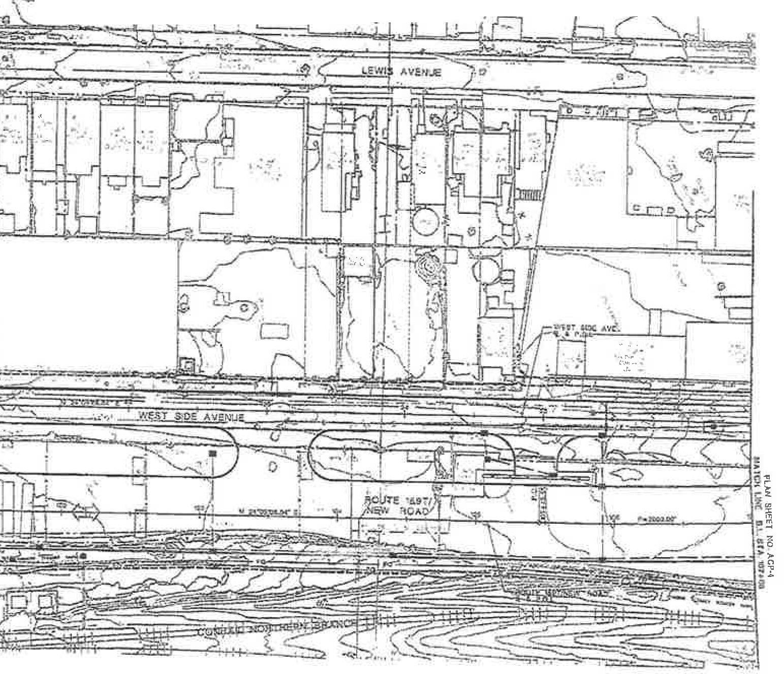CITY OF JERSEY Cl1'Y COUNTY OF HUDSON ...

, I r, - '

n I -- I Ir,
1_ _ /
·,.
l ! -\
•l nl
I
.l
-----

i:Je1';T!1-!C, ."-Olo' i.lltf

i
1

ll
•-=='-• ,J;" ""

NEW J;1sr,r DQ>.U1'MlN'I OF nA.NSJ"ORTAllON

a Na \itfATDc. o r 'l'Nt IJ.•,! •t.Rl A uff ACB THlS JMttt
!

'S:iJ"i

USACE PERMIT PLANS
R:OUTE 1 HT,t.lM ROAb
k ,,.
CCI<"o'JIAl;TS & :)
CO NnJ..CT HOS,. 00011!000,
DQO JII0 10 £ OOG1.ICll 2"C
"'• ®
&i_,"V(_ l\ 00

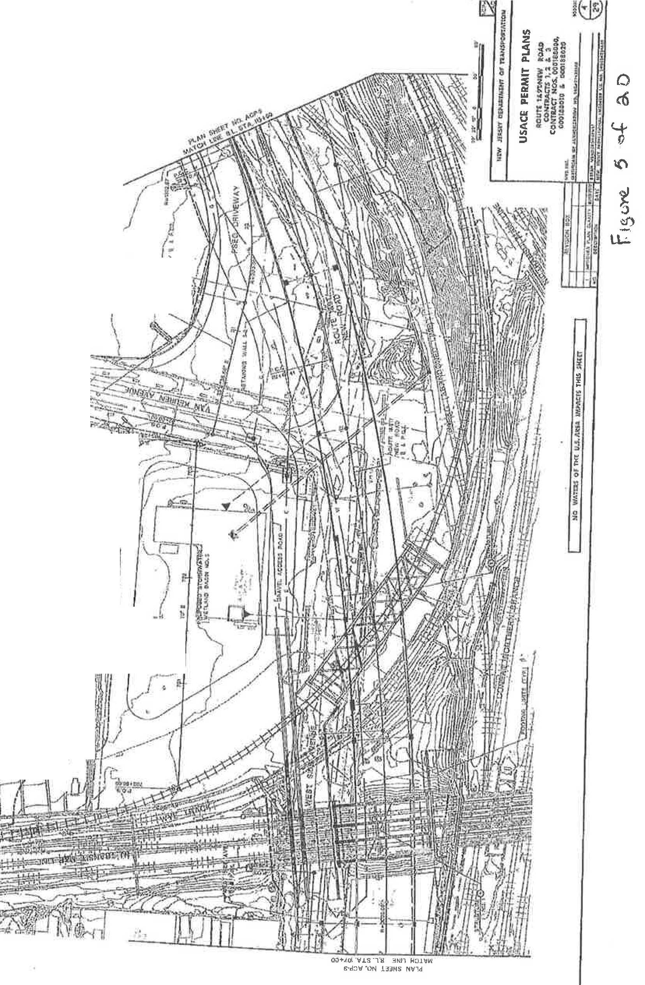7
I L

¥/I'I ,
/r
. - /)

. \ f

l,

-..,

·
..

I ,
\ . Ii i-

"-I"
LO
.'.q-"-
0
r-I-
0 """""
z z<(
Ct'.'.
c^{L}o^{U}·
2
:z::>
LU
-1
lL
uw
t
/ Ir- /
I
../ ) \.
,,.-,,
5
,.I
/
I . :

<(
Cl)

I
,..
{f
I

. "

..
-.;;t­
L()
-.;;t-
T"'"
0

I
l'---
T"'"
0
j''

! ..•

0::
w
m
:z:J
w
.J

/./ )

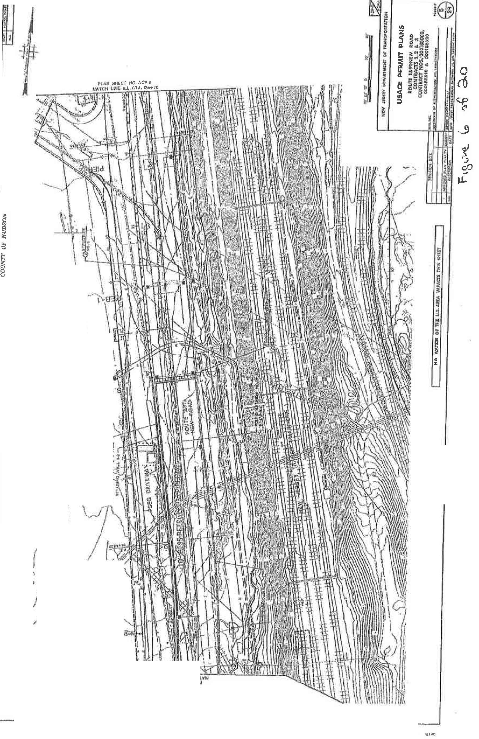u:
w
0

:::::>
/ ,,/
= ,.
j
' ;I;

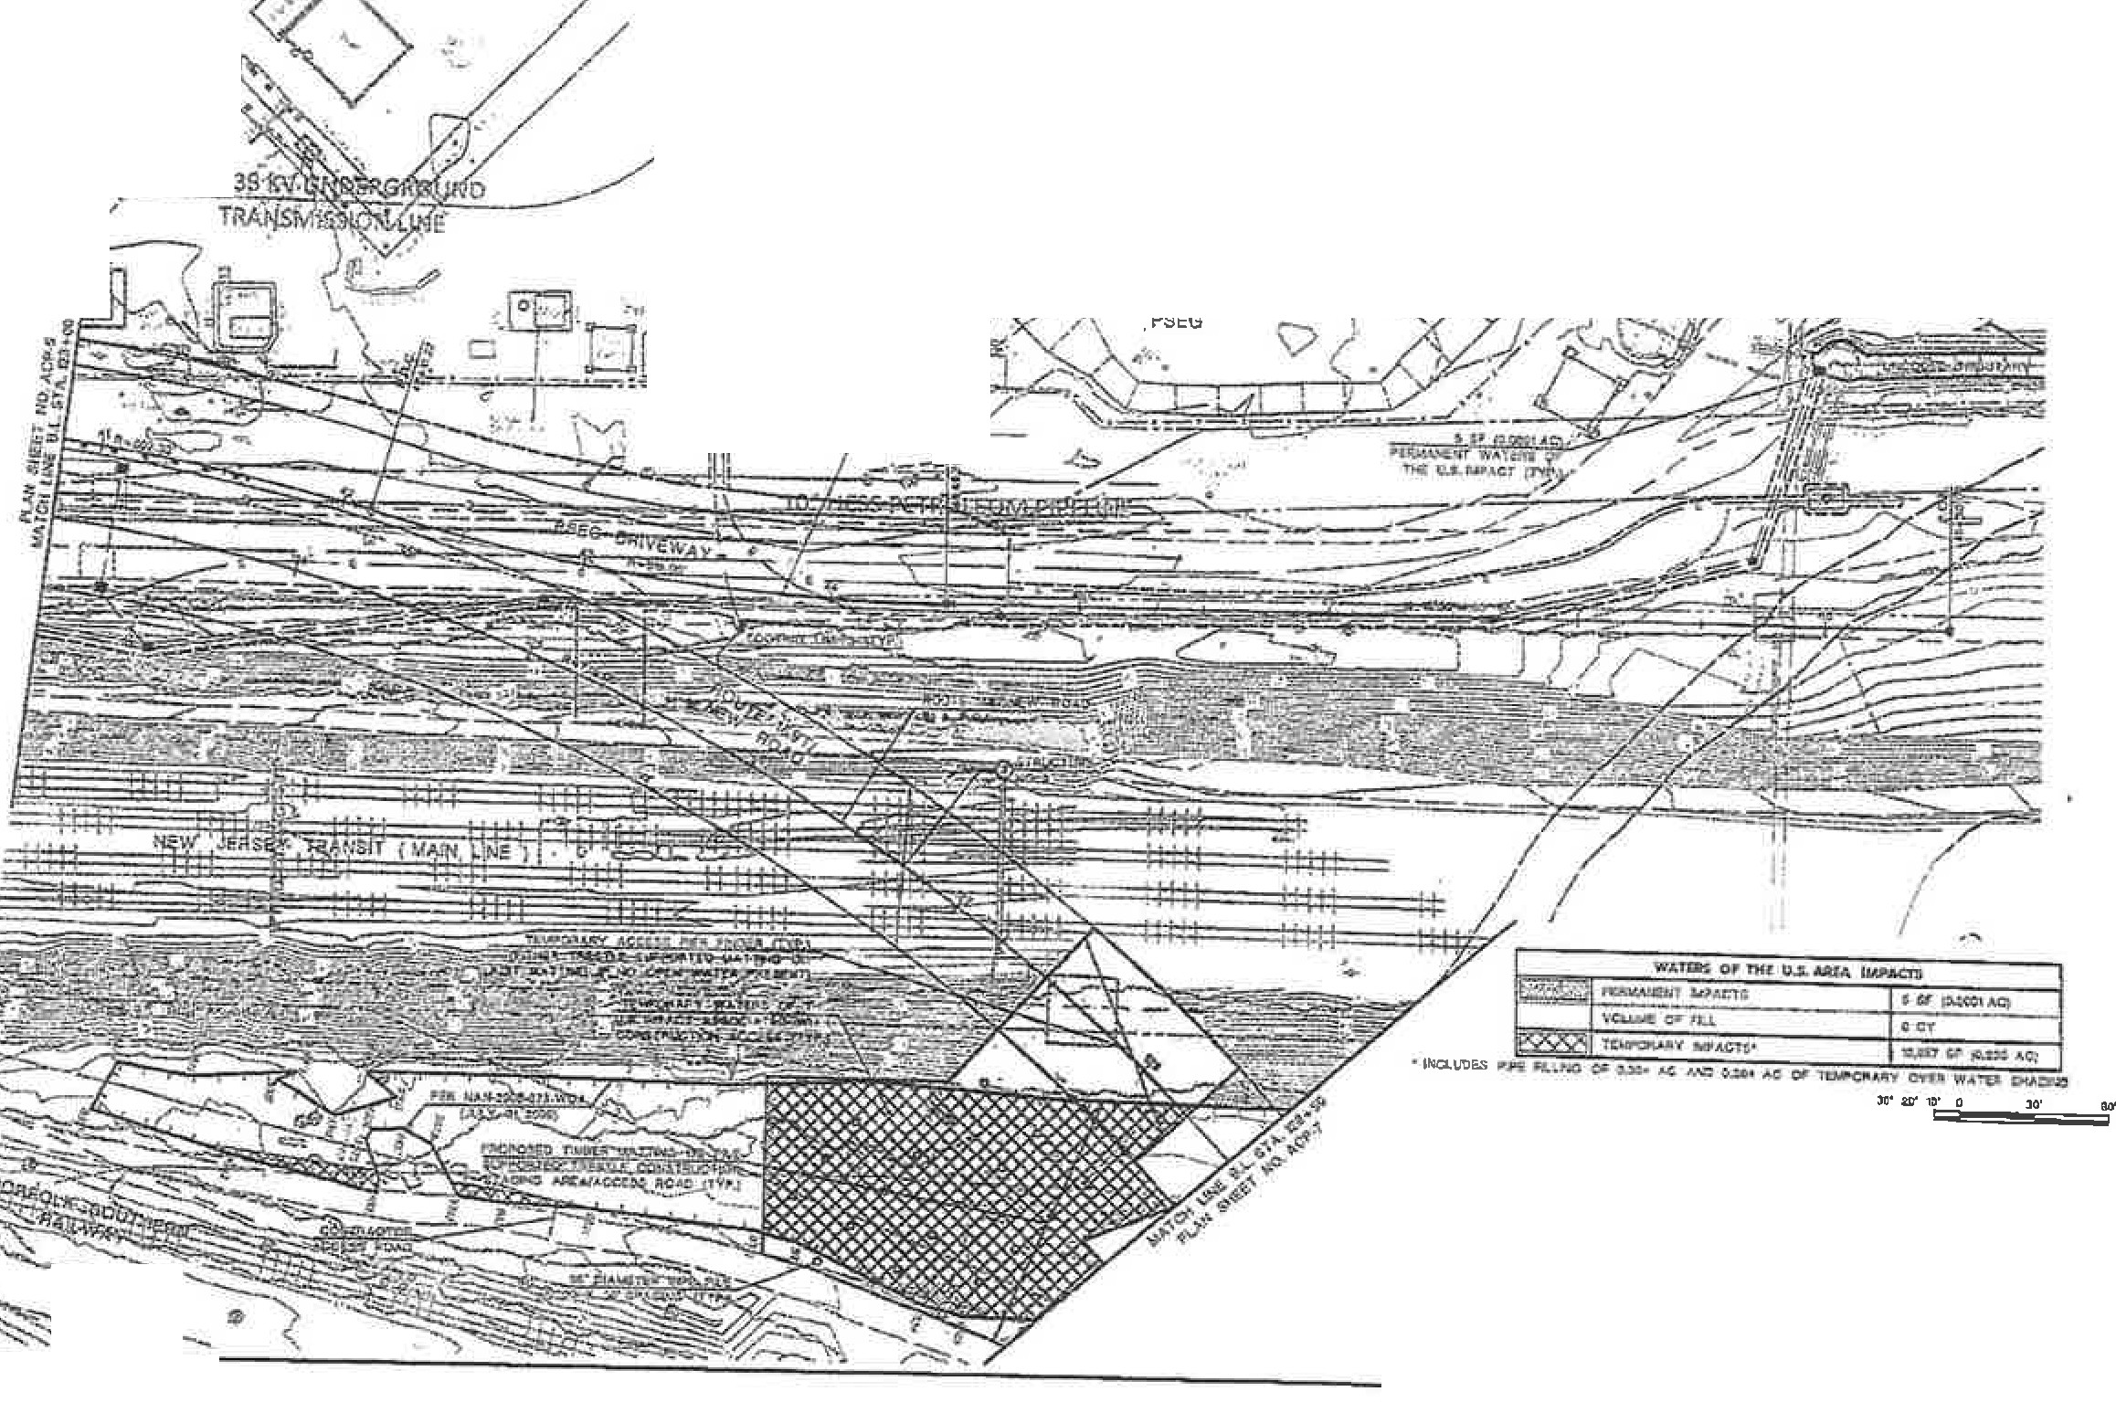USAGE FILE NUMBER: NAN-2017-01454 -

F:c,r'rcrm,etaOtite M, 1
c.: rW• ...C...,. NJXJ , - ••11
CITY OF JERSEY CITY COVN7'Y 01? RUDSON

,. ,,._..,,_ U .. •fHl:t
-. ,. l PDlllt\l -H;Uifll,lt MIMil:!U. e;.;.r N'°f

t.,.
Ua') ttGatalm taD)I.C., t'«;
c trtkll'4:1&Waiwlaf\Ot!NUlt\

:-J!!. --= ?<
:! C::f.!'=- tl=n
SIM 1- a.t'IQ l'IIJlillll_,_ tlA:MC
;..-iaa.sk1•1ir.t .-•o.llib1U:llil
er. - .• / '
' '
" '\, >

=-.Il.l::-.. )ICl=-:s" r. /
( :2(•1, 1 ':",aw"° IIV / "\. • .>1,

lr.f
._, l MI IN IIIOotHilby 1,-. w=0 T ..» O • p'G1'11 1 1 cc:rq- ,-. a .-a;.J; n&l........11 0.:t .... ..,,,. •
:.._...-i..1t.1
-c.u,_._.,
d tr;..1ir,t .,.,_.., I>-.
'."" .,. ,rn,.,,_ ""• '-.. ·I ' '-._ I

'-../ r i L-- ?'·,,/ C?,/) ./ }/[ >.,.,/ '--...
- , //· · - / ,;;;· \1.
' . . i
/tK . .
J
-
·01:,?;'

1!!!;:===:==:==;-{"'T7
'\.. .J - .
(1 <./ , 1/..ff

L-O
b".
lr-:i ..::: <'{ -

.• . . •=: . - ' ·
j -

c..,.TW_..
/ ---. -. 1:-b4Lkd I ,../ '

A •.·'.=

)t' 'O' 0
NlW' J!IISff DEPAAJMINf Of nANSl'ORfATIOH

. '·';f

1 u cos
USACE PERMIT PLA S
l;OVT'l U.ft-N.lW ROAD CO)t'TUCJS l, 2 &.
CONTMCf Nc». e0Olll ltO0,
OCOlHOTO .& IOOlJI0%0
@
l ._.u,.. -.,,_.- ,.
:-:,.::::::.... _....,._ Ul. _ _. 1Uh

..:.:: . '-- '
, .;: :; 1
15,,w._ '9 ..('. d..0

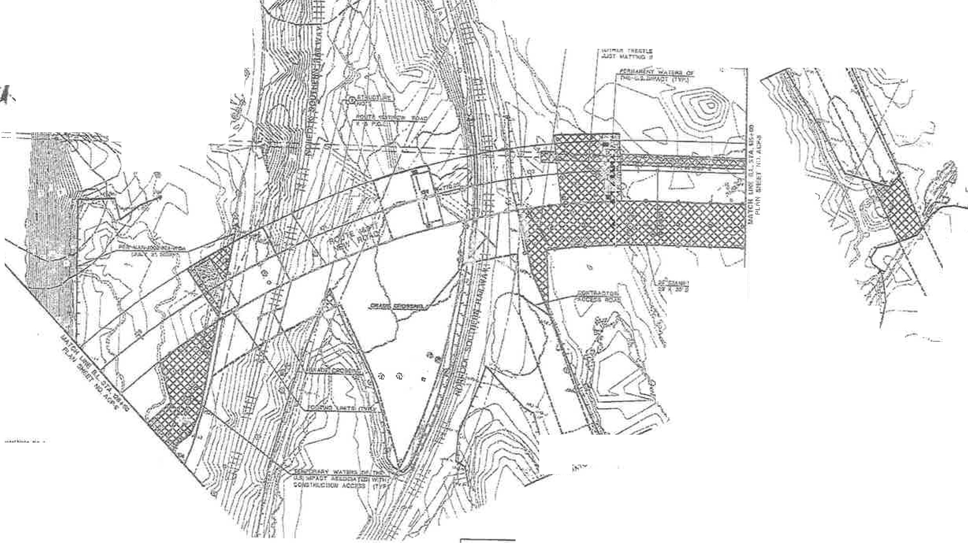USACE FILE NUMBER: NAN-2017-01454

__,(\ I l u\'
CITY OF JE;RSEY CITY COUNTY OF HUDSON
1

.,,-,:r:r;-: ----.-.--..$ -..:,

1 1\J \ ) \ i ,
''j"v---0 - - ••
.'.

I I. ) I Ji \
, , u··- ·oi ffi,i' ,;;:, =-::='.:=J =
]!\.

/• r_· G------ / lli. t
' ' , - . ,...
. v t

I I -I ...'"?Y ' I \
-.. _, _ti! --Ir-1, -,,".-..' , / .
-- -}"'" J' ·, ;,,,.i.
·- . ..

_. ...,
_ ,._,_
-- -:...= -'?"

I \./
•• i\..i{ •• rr a-rr. ,._
\ '( \ 1 ,,_... ,_.,,', cJ..,,
•,• ',
.4> '
l• .,.
,(
\ ·-. J "--
t .. /
\ / /
4
\ X _,
(I \ / ,',j"'
\ \ / ;y

....-....,
.•.., \ \ .::::--·..--....,
- } '\.. \
,'h \ W1'_;:.-.)·,
(" \ ... -;;;: .
' - I

\ ' \ _.,A" . ..
\\v
¥ /,,?-
i 1 : \j. -
, ,-.·.
··- \,

,,/
:
\ ..1,
, : ·

CWlll'.K :1' ..,. b!l!t,,,, 1111iu:1:11 ht'[NO U..
•11- ......,.,:1·
N.r.::;. 11.
..... tt:!'N!,fi'I' CP.i+.---»-- - Db bl#'•
,._,Up IIIIC...'.•,_,•.,•·1·1&t.ry.'vl1.'n.., O--."""tt."N-t
a•••
'cl·"" ) 1"i .,,,-:n ¥ .-e,Jl,f
..... ")I .,_.-.UC!"••tbLO)tM'J'.,s
l H- n:tl ..,._(I>,
"!_ C' --=-
<>' }
y
:
i' Nffl .TtRKY Dft>AIU/dNT CF R&NsPOJlTATll)N
USACE PERMIT PLANS

,.-...i:--=•41 ni4»&A.
, .:!;',::;", !
;:.;;:,"::; ._.
)t t ,u , ...711/.6': /'" WA'l'g"I, OJ ,HE ll..i, 1,1(.q JW AC'1f:=
- ';!,= of

111,r.Q w:i. - $ 'I...
....- " 1i/!(JIM \ / IIJIJl{/f. 1/f· - - - - - - - --- ---c----== ,

r:o tn tA CT - 0-, 111,0 000,

I :::.::..= -=• ;
n>- _,..,en. 1,";.I s,,; (o. f(j .
w:s.'"" c cot uo io ooc:n•

ua.:•........
VCJ,liill!OfFG.!. !2tJCV n:!.- tell'
a.>lfl •-- Alf,i -. 11u _n,- @-;11

! j; b.._..tA. .._ llt'" H "Al l!!,,i!,l!,o!l..;;:::.::::::.;_ = :._ - ,.,,-= ,_1..;;
·
tc-C"
;,..,:;':;;;..;.;;,,-J.
n.o.T'I'

,i.,r,,.,,,i .._, 2(!
o11.. 1..,._, ...,., _,....

11 - - • fh-,. .t Y Da' <i.C'T., , !!l,7M , r .>•
r:F1o , .,. u.o_
.:id•r "'fNCo-i:/U.:;;r. \
'li
'F\il. '6 o(. 0

.

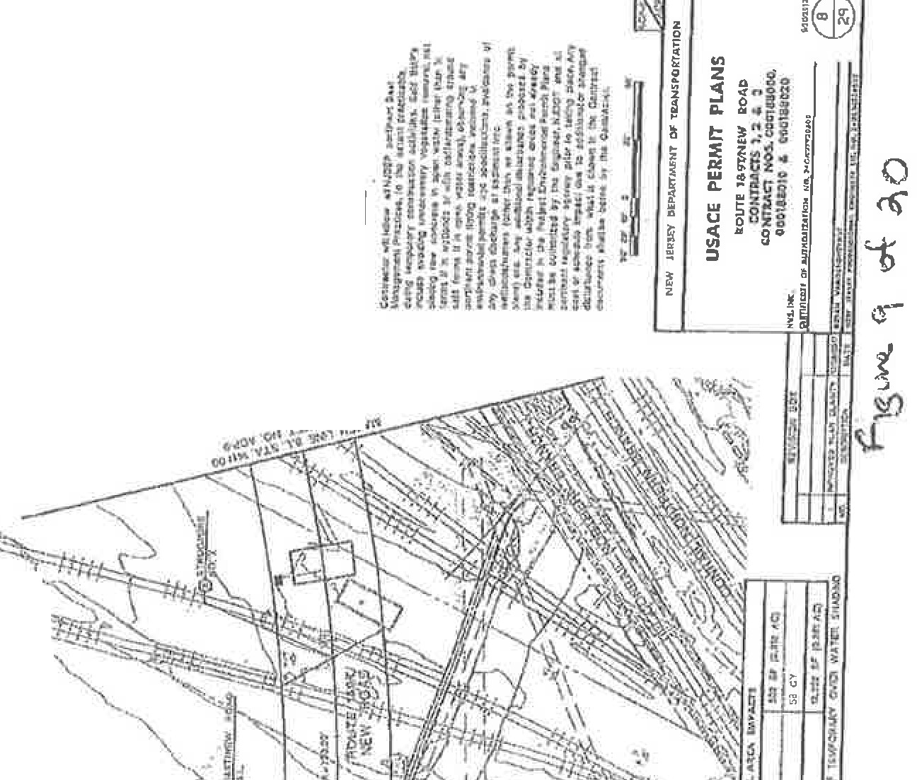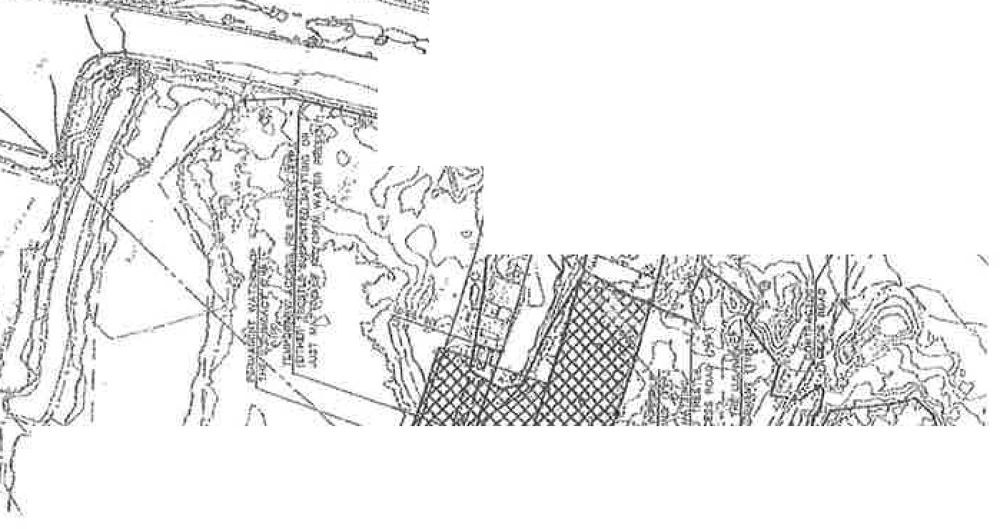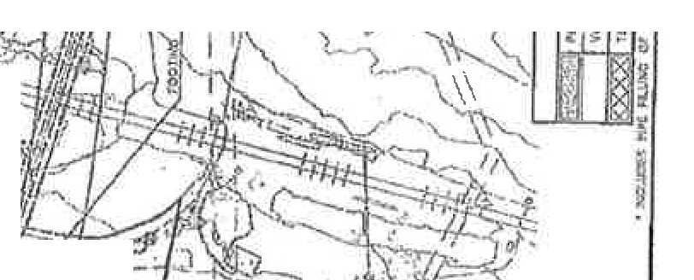.._,.
'7:;---.- \
.
--
Ti-?fi·_.-.
•-
::
·--
,..
)
5
- J
---
- ·---
.. •
.
!r
eit
!!I
\
-
lJ .I;.0
·
--.& ~: ::::: : : :: J
--
.
''\
·,
j
/,·'
{
LO
"'-I"
0
r--I - !:
'
u
0
N
zI

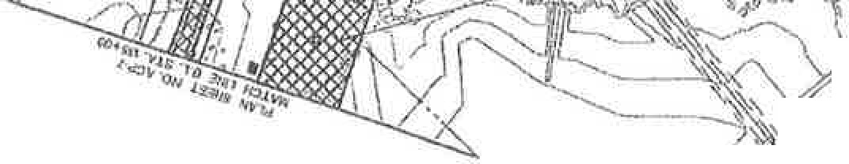<(
)
-
, !(
,_,

z
er
w
Ill
:zJ
w
...J
LL
w
(.)
<:(
CJ)
:;.,

^{.-r}-- n: ;l!.k
L

USAGE FILE NUMBER: NAN-2017-01454

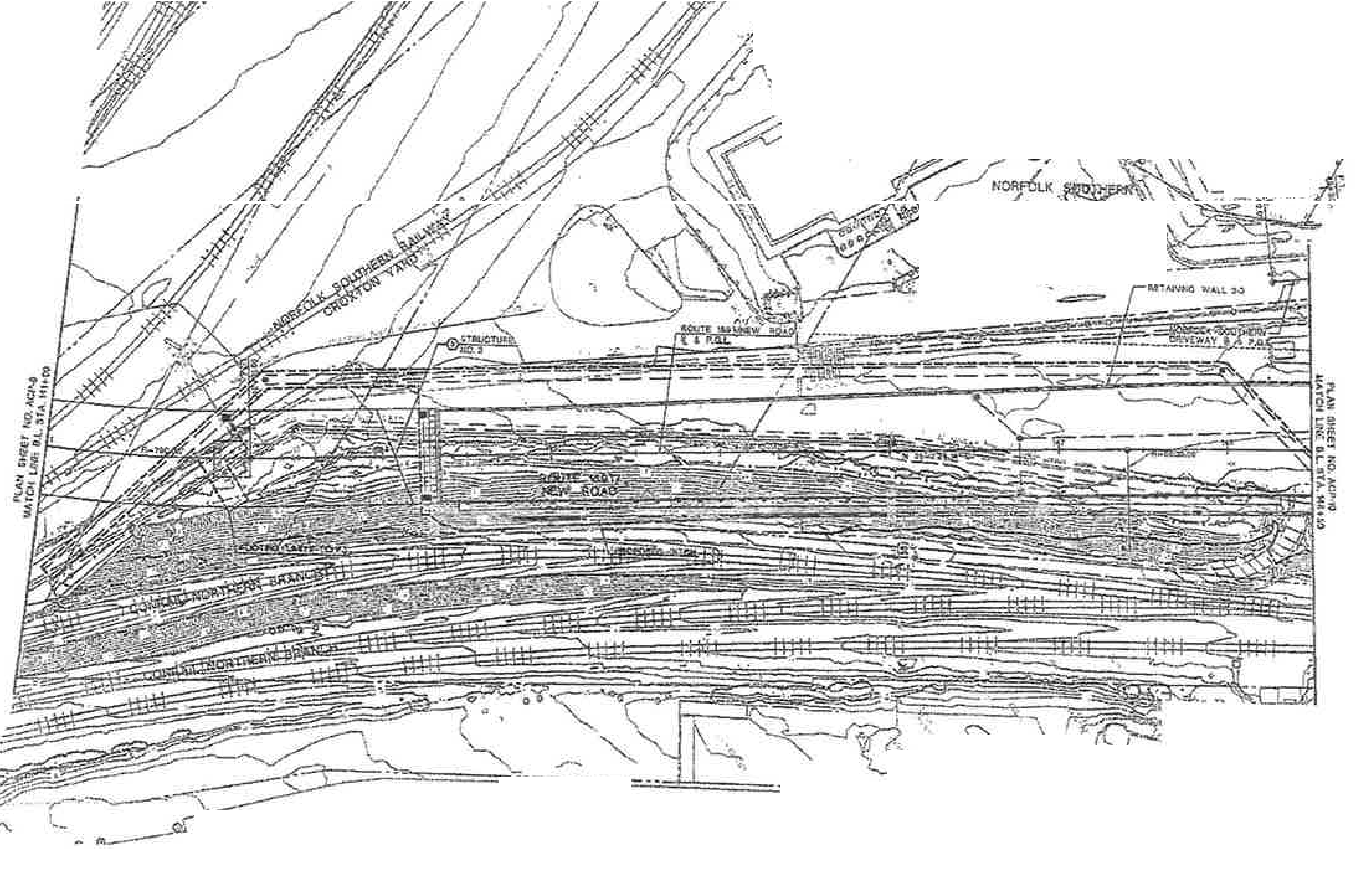CITY 01! JEJJSllY CITY COUNTY OF HUDSON

,.../ .
, .' ,, • .

-- ,.
...... ' '-J-4-'l>'. "'-J

A - - &· • " •, . '-.......P.) - "":

' 'll. -.,._ , ,
vi., / ':\\)_
\ • \. •., :,'fl.
..,,.,_
"'--
- ./

.. / t¥ \ '{, . 'f /

, ..
""!'SP. 'r ".7"-" ).. ,
,, ·-
,,1
, -\::- ·.,,-=: l

. ,. '--..-.-.-..---.,.,.---t--- -
·-'
- r .......
.. _ · r;r .r ,,. .
lrlEW J!ltl.EY Dl DF 'rlANSP'C>ltTATION

USACE PERMIT PLANS
- oU'TI:: ••n+aw a.o@
COP'l1'1ACTS l, :I t. :S
CO CJ , oa0l8SC0 D,

HO '1,141'\D Of fflJ1 U..S.AIL\ J,IUM;rS. "T)QS.Jxm
.....,..
,.-;_

fftn,
OOOU:IG l .& OOIIJ1Ut11,C1
@

?! , ... ;- .-.... -
'5" i-0

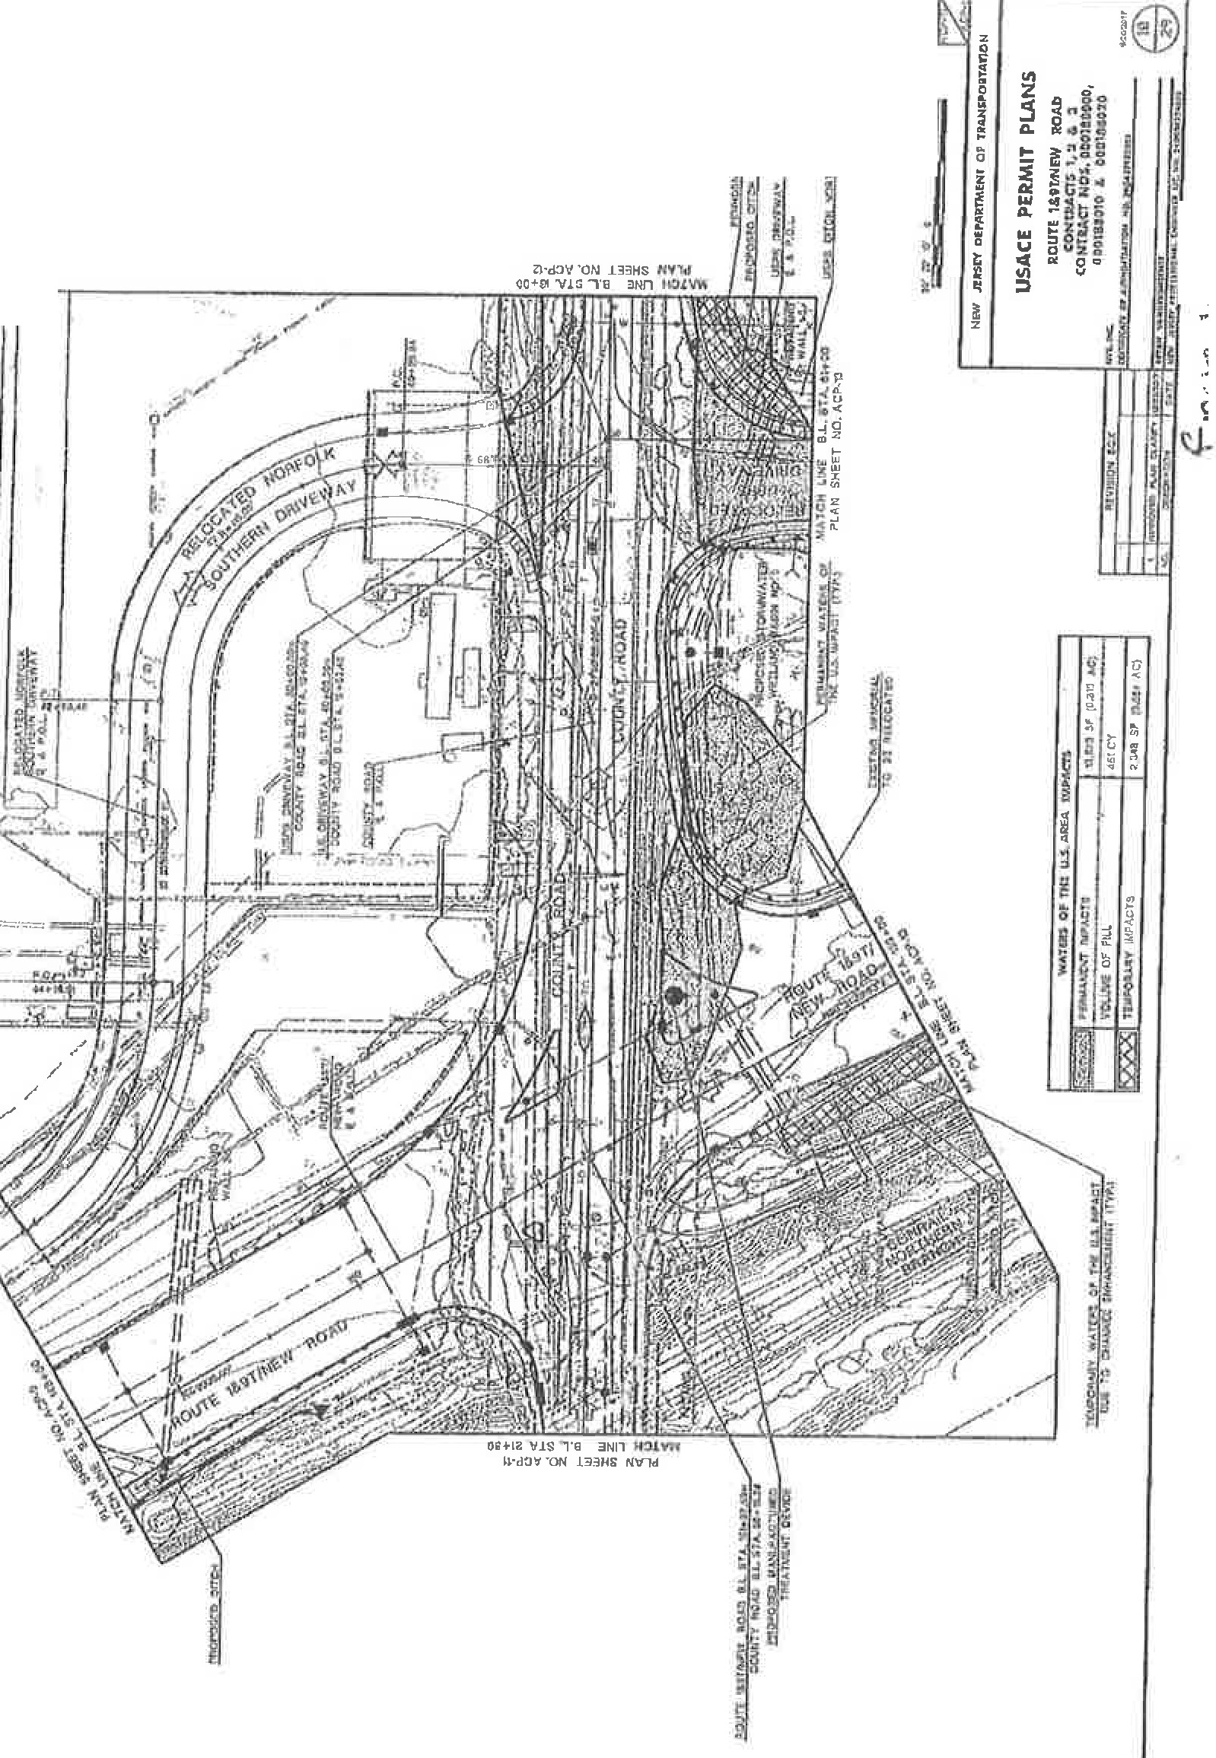iv
I
I
l
0
. (6
j 0
I <>t­
=
::;,
.'i
}
0

0""""
N
· zI
z<(
ci w r;:o
:z:J
w

u^{-'}::
w
0
ff5
::J

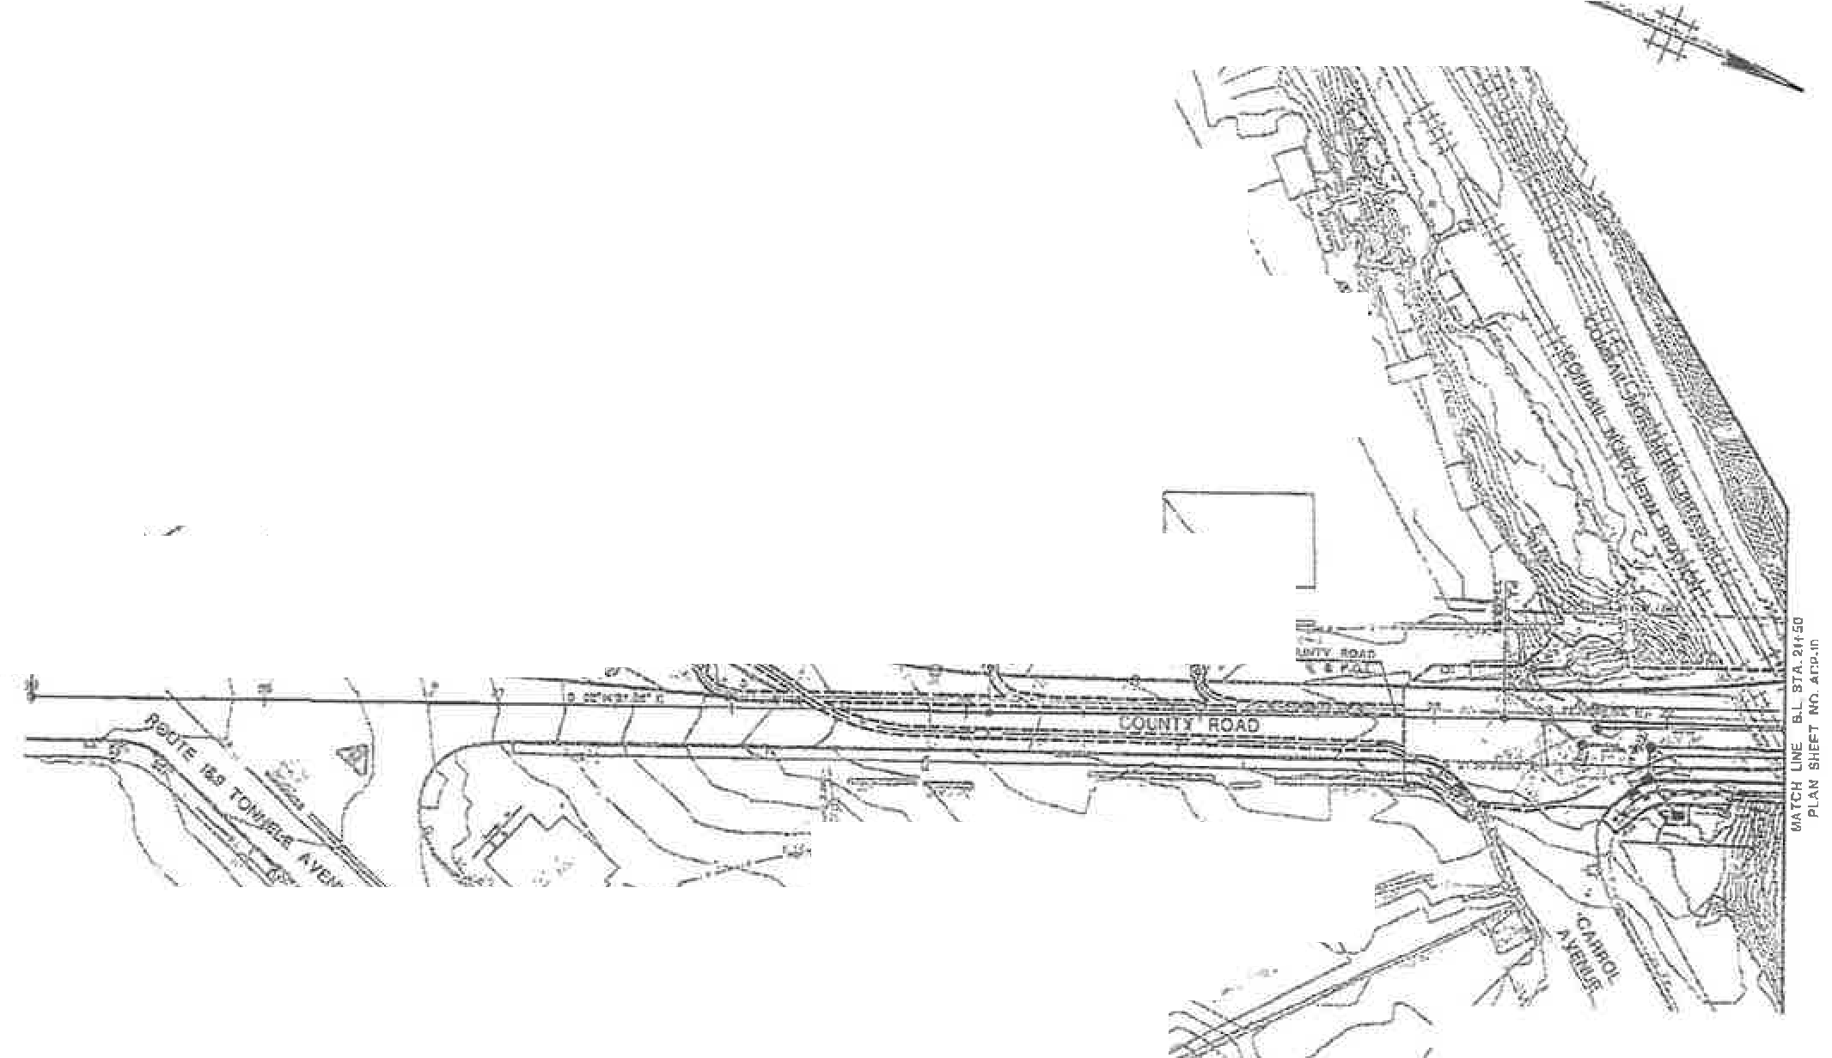CITY OF JERSEY CITY COUNTY OP JIUDRON

\ ' / \\ I.
\ .
/\'%..1. .G. , ' ''\
\: \ '-"" .".\\\
,,,_t½

\\
(
-. , I y
. '·•. ( !
r \ ,,---..

---.- -
- - . -''-l,l....
.v ..,

·---
. ·
,
l 'F.f,--
,}
•.:,.,, ,,.'!:J·-), :[- •
"\. -
\,._','.....,.,.
.l

,.
.

- \M\ J\

'1· _ \ ( .
- I I
rr.· \
/
- ..
t-i
c- •
-
......
,' ""' .. . =:- --..J:
..

' :--,. .,. --.J '· -., ;
-. Jt \ ':::----..

,::

%

"t",: - '-- "' ' :;,r - uiili'!IIJ

•', "-< V :". - \'¾• , h .. ·
---::.. , ,-• .;J-t"' .'
. \,'--
,. >.- -
  - :
''>= •

i
--. l , :- ..._ 1 X·

'J..f>

'\ - ,-,. ,_ I ,. ,,,_ ,.,
' / "/'\
'>. '

'\. '""\\
·.,. ( _ _, L
·,

_ ;r'

tnw .rwn OlJ.AAti'IUl"T o,, n ,.ta HtJl t 4

I No w:.ms 01lM£ u.;_,.,.,. WW " .,• .,. ,.. ., I I T.....~,.· a- 6-"1 ""I !

USACE PERMIT PLANS
ROUTI \1,91,,M;W ROAD
-
CO l , l & l
cmnua »cs. 000100 0;0,
0001no10 & l t.9020

I

I c ::::::1': i;1:r.11 ,o x_ _l C"
11
.."llpol _ ,

._, I •-=-e;e --:- "'t ..a- 1u, ;.
. - Y";on.r:-::n-ne, @

l=-1 v'\.O- \ ·'J. ot' c

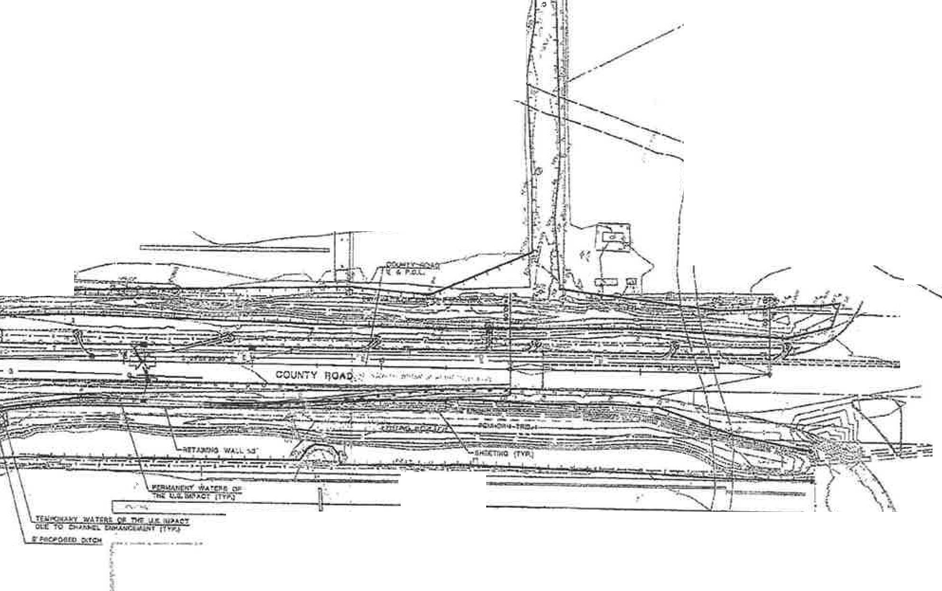CITY OF JERSEY ctrY COUNTY OF HUDSON

I \ \
f '\, ",
l
·· · - ·- ,-"......
/ ,,_
\.

IN 11 olAlf _

'I'•.
I ,, '-.......,_.......... \

n·r:
O-= -=----=- C ..........

;• ..
I'-

NDRFOU< SOUTHERN

I \ ·'

,,
'-' - '-<.

,'-,

----..;;

" ' /

- D.
'
;[
'<·- "' ---·-

g --- - ----=--Q--'---
'
- . " ...<.:"_'<,;:;'.

i
-
"'
·

' n"-'· 1 .z.zrm,r- - ?fa,1 1

= --e: · _.. ..; -

.... \ 'l_ _'-, --J_\ i

. . ., . .. .
---------
/ I, ' - .

1· J!; ' ;
- n' t1' f) .. ..

!' i
I
USPS INTERNATlOIIIAL & BULK M IL CENTER ,//
....;/ ..

:D5Ef' ODi"MfMf 0,: U,U,IP<MI.IATIQ:tl

..,
I .,...
.7 ./
_,,,? _,,,,/
i-· -- ,
. ., , . II . ,

USACE PERMIT PLANS

\,.>
i
ii
,,.-/ -,,,_ l
'WATUS Of 'tftl U.S. MU. 1.MtA.CtJ

-m :;,:,.

ROUTE 1& 1!W ROAD
COMTt.\CR t. :a. • ;a.
C0UTAACT tJOS. OObl&SVOO.
coo1a1airo & oocna::imo

" - -
11'11:a: !d)lT ,. ,cm: | I \f,(O -II" | AO]
o,n.,:.. | "'ty
11.we•.-.av NJ "-at' ':l | • | •3.

_;i,,t-:wi<n L .!r.
.. :
- ••n·,-,,- _.-- m1L
@

f?,s..
13 ('.r"t ao

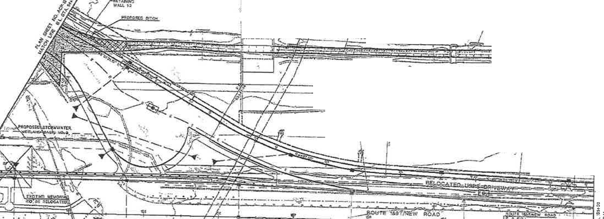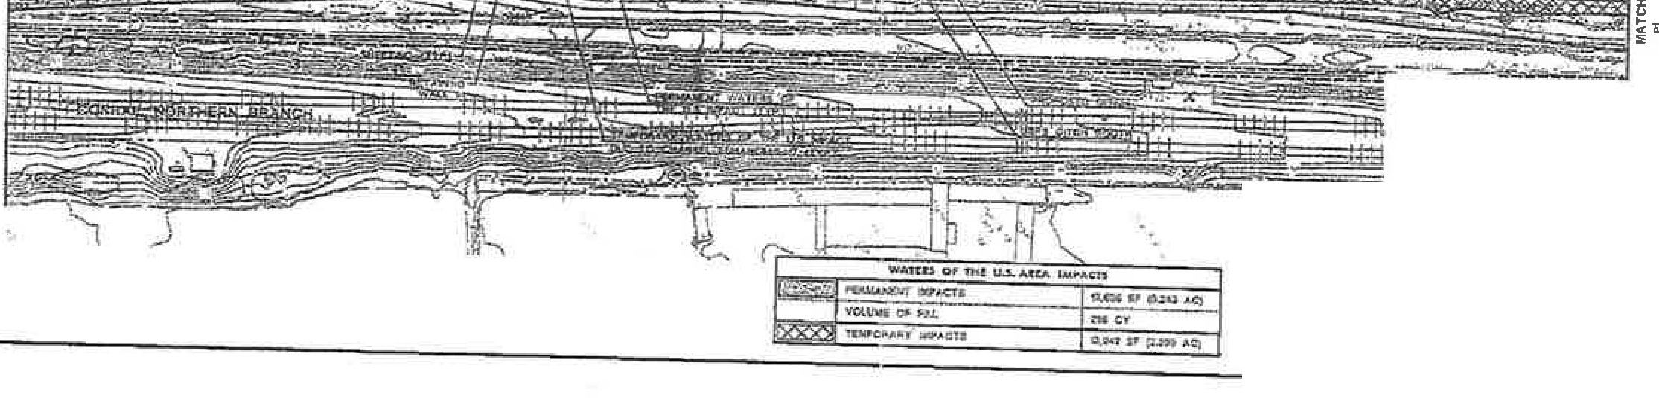ClTY OF JERSEY QlTY COUNTY OF HUDSON

..,, .l 'J
....-. .£' -.J,7I·

J· I'
------
·-'tJ- . /

. ..._I/ I ' ,
' .•>---
- (iy'lr7.I.

- ::.-:
:,. • ...;e;., ,. ·-. ...

--;--;- - /'

i• ? --.::Jt,, --;... ,. y , '.' j',.;-IR-
o. ,

r , ...,.,
-.."'"•-·-·=J .
,{_,_

':,11 •

§ :=7i = :-;. 1- =-=-=-- -=--=--=--=--=---===--==--=-=--===:-:+i B<l,
.-R.N..;I_O·I-IA,L &

B\J\.K t.Wl CE:lm' :11:=:.,

-, I L.._.
"
\
'\
\ 1 .U f,

- - • i I" II, ,.:aJ.."'fU:'!tY. ---t\p
•

R0#.0 rt'r-:fr=,_.= I !6
j

i>-
>-
, i iii i i ---..·..·
, ...
...

•
. ·· ·: ..

=

.-.- 3!
- G
"
"

;)(J' •'O'._ II

JUSff tJP-ASTMENT Of 'lltANSPOIIT ffCIN

USACE PERMIT PLANS
tOUTI 1&9t,trr,tEW lOAO C:OHftA,CT:$ 1. Z -1. J CCNTIJ\CT NOS; 000\UOOO,
@

,- - -- - ..-.-.-- -
b .-. = = OI G I, GCI01SH20

.!!L..lii!!i' .JUv- •..,...jn-.,
tct., w. I
•• :a..- - ,-..-
O

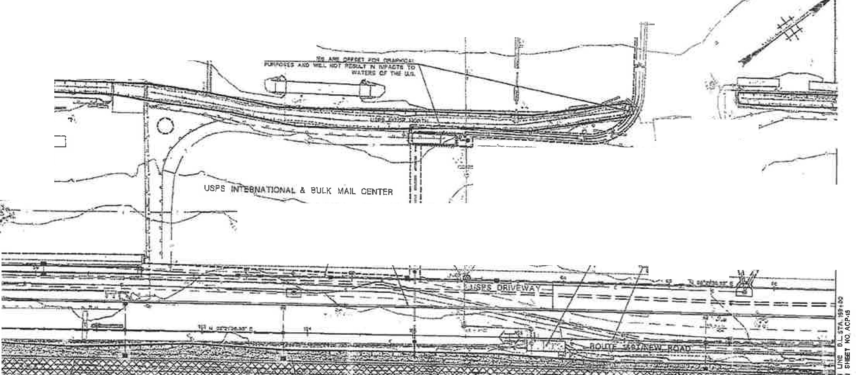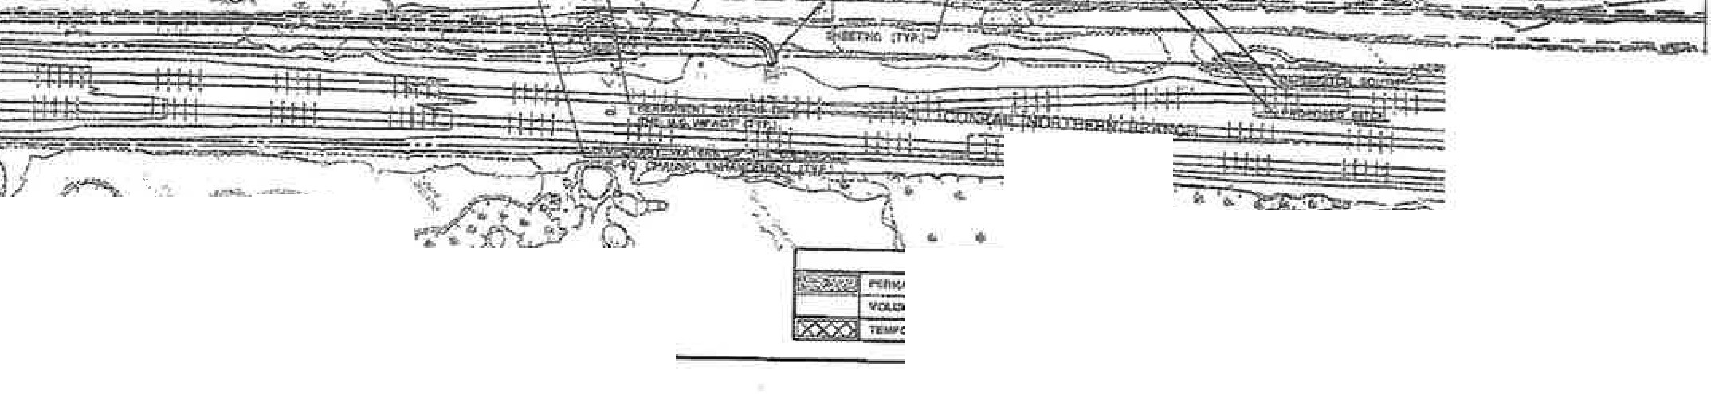CITY OF JJSRSlrr CITY COUNTY OF 1lUDSON ...

..,.-------------- 'U

"------1 .-
:.
r- ---
,
i ::--, '=4 ,¢1.}
1 111

'-.,
l.....- - - - - - - - - --'f-- - ---ll-- - - - - - - --!-H!-- -

,"" -- 4,- .►---;:== -=-"-;
........
1 ,. ' • ,-
i ., I):
R.YC \;_ ;)
.

- --.-=

"'" =
"'- -1il /Tf-
\ ⁻.-
-:,;::;;f ·

.,:
.........._ -
- :--.,,. 1 1l11i .
\;) ·-d.-JW.-(? -"--J·x
1

_ , '' \ ' /
gr...... .
l'- •·
/ "u"i"i'"•tr"!."6''>o,o._.;:- -:::" "I •\ 21-..
,,_..:n ,

.t.,
h --
C
g

...ff.
- - - '!

- ,..;;,-- - --==::--.
; d ,,.,
'5<;, .-.;·• •• •• J' Q
. o , -·

·=·-
., _ff O'_:- •

.tHW IDlff C,C:,, #,Dff :>f' Tt.UC,H»Cft.ml"-'

USACE PERMIT PLANS

)(Ir......:• " ......
' I , \
, ·
\ '6. ,".'.-..,__."'
• • _-!:)'-i..,.'v .

wAl12l or nrr o..s,.. uu. 1w-.m
..
/ :, 17:"\ 'i. · ::---.--
N:ll ACIU: ! V fl-, ...\Q
\.ClO
IOUT't t&RN l'W ROI\.O
C0 )fflt"4=U, l, 2 a,
-
CotQ RACT NOS. OCIOldOOO 000\16010 & 0001HDl.G
®

OF flU. "'ev
" TEWOt"AAY ::..O ::U 1t,Mt 11• tt.
'f,"lifi•T"w.,("
:ir

Sv"'-l \5 ao

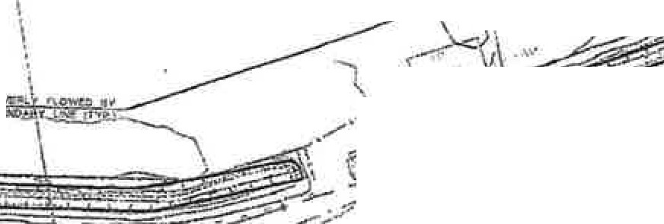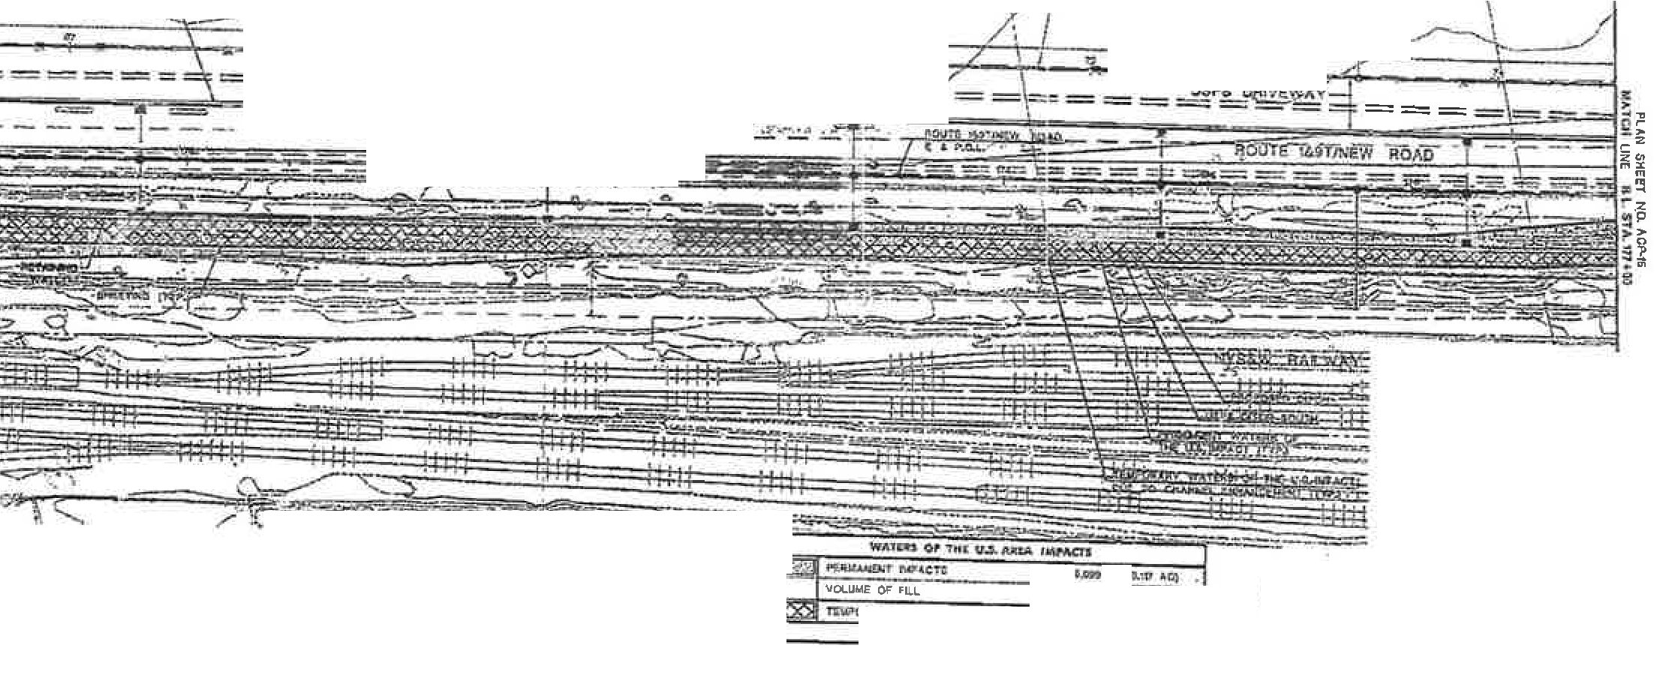L I _::__•
CITY DI' JERSEY uir CDUNIT OF HUDSON ...

I ' j
,I

USPS INTERNA;TIONAL 8ULK MA'L C NTE,\
  - \ . \ I.
,,.. -·

· • " ,.

_- .& '
- - - \
·2 S -. .·_.: -Y.

- . ---------------
·0s e ffi
· , ,:::_---

, .-£
--- :;
.----- -L:__ ;\-
:-¢......._:--_J/,!-£}. , ' )/

-- ·/. : \\

i I )

"'
I •
\
-' r-I>
.\ \

= === = = -== = = .----:.- - -
:s:::
PS o;IIV

%

z
9
i',
I

- - = -- ..:..-.'-le-
..,-.--- -
- - . - -

· ::s
! - . ,!

· -·· - -- - · -· v ·-

U lft t :f' ,J. l ff' I'?)

NIW JU,l'Cf ot,,um,\fkJ Of A.l'I

USACE PERMIT PLANS
11oun l&HNIW ll'OJU>
CO.tfflACT$ 1..: • ;s
a, ,-r,_QJ,,a NOS. ®-DlHIUIO.
0001UOTO & OOOlU 0 ':10

'olOLUWI: OF 'll.L ""OT
- l -:1;....

M->

"'ii
T ,..,.,jcu U\'l'U!A.%01..C!.

,. G.Utt"" !.
nna _,,. ©

1<3-.s \ b d--

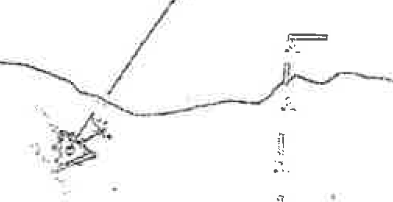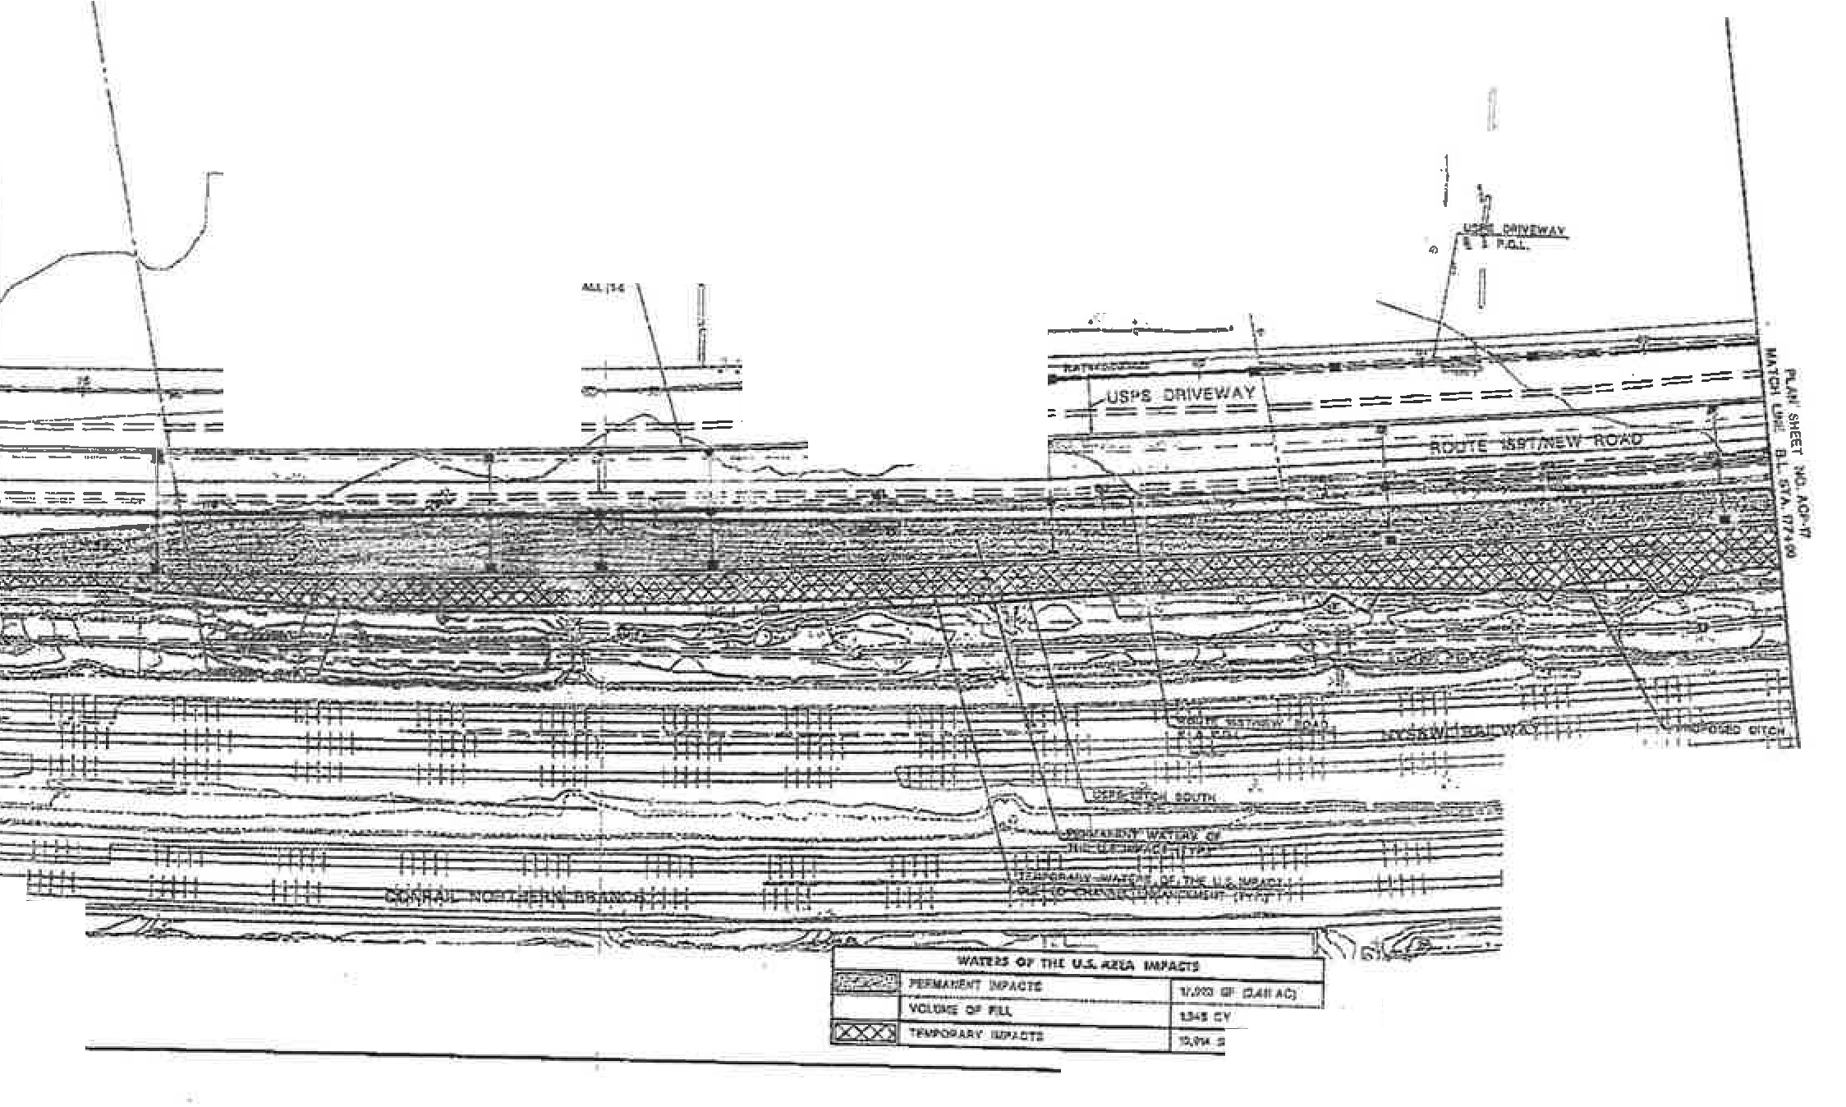CH'YOFJERSEYCI7Y COIJNIY OF RUDSON

=--;=:
-
\
- -
, USPS lt-fTERNATION._L & BULK IAAIL CENTER
- --/

0
nu

--.-----..-.,
::l,,--· ======

i

-
\t ,'>';3 111' 0.,tft,lC)
I
l>'J e·,
s 'J.t!T.: P.tw 7(1,m

-"··-·· -· ......-..

X's!t"r: K" d

USACE PERMIT PLANS
WCW JUS\Y DP'A.t'l'*lff Of' ATIOH
'IOUTI HnNIW R.OAD' CONfltAC'l'S 1. :, 3 amntAO NOS. 00011&000, '°°1U0lD & 9110-:0
@

rt. '"7 { ac

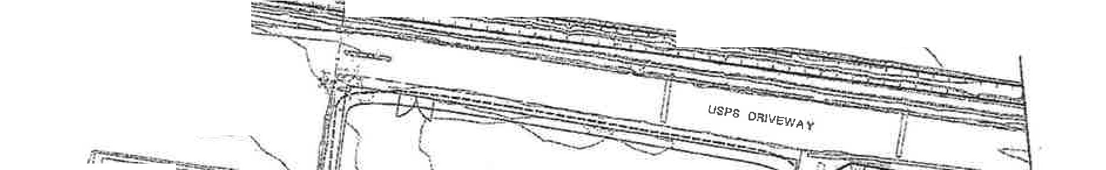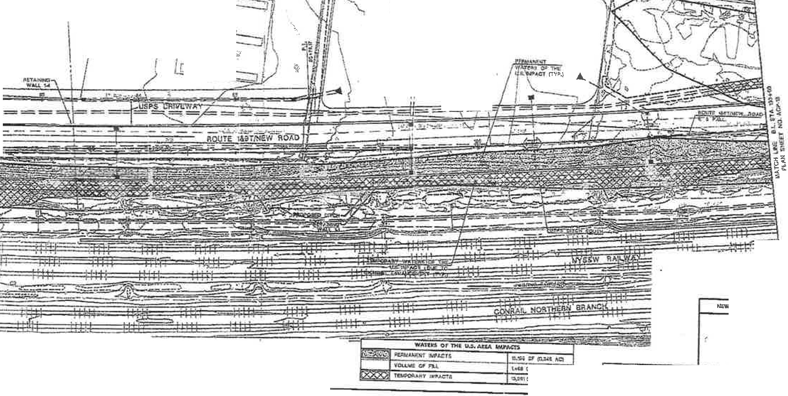CITY OP JEIJ.SBY Cl'Q' COUNTY OF HUDSON

,1.-1
-;
l
'_J 1 .I/1ll¥.'/

USPS / NA TION.,_L
BUL K ":,Y- CENYER
-: :·"1lLb ,'--

- - I
--=- ? -
--r-.

---.. .

-, - ... I. \ t

-----J .
· ,
. ., ^{J/}--:::.'.:.⁻

\....

c.
\ ?llWOPE'lDLSAENDO $9'""S!"H"N"O",t. "
\
\

.'.:.
I
:eO::g-
s!IJ C-1- -
!
:
k - ....., ·
\ l_/\lvf

,-=

"'-

JQ51!Y CIDARTMINr OI DAN.5POIT.U10N

!
•
a.s;:, out'

USACE PERMIT PLANS
ROUTE 11. EW IOAD CON;u.cT&, . 2 G, ,:II CONTRA.C-T NOS,. 0001800COt DOCltlGOl O .A. 000119«!0
@

\.•U c:"
- ,;; c.=\AQ
,'KO ......_
'I!'!
9-:1s.,1vi I Cl f ao

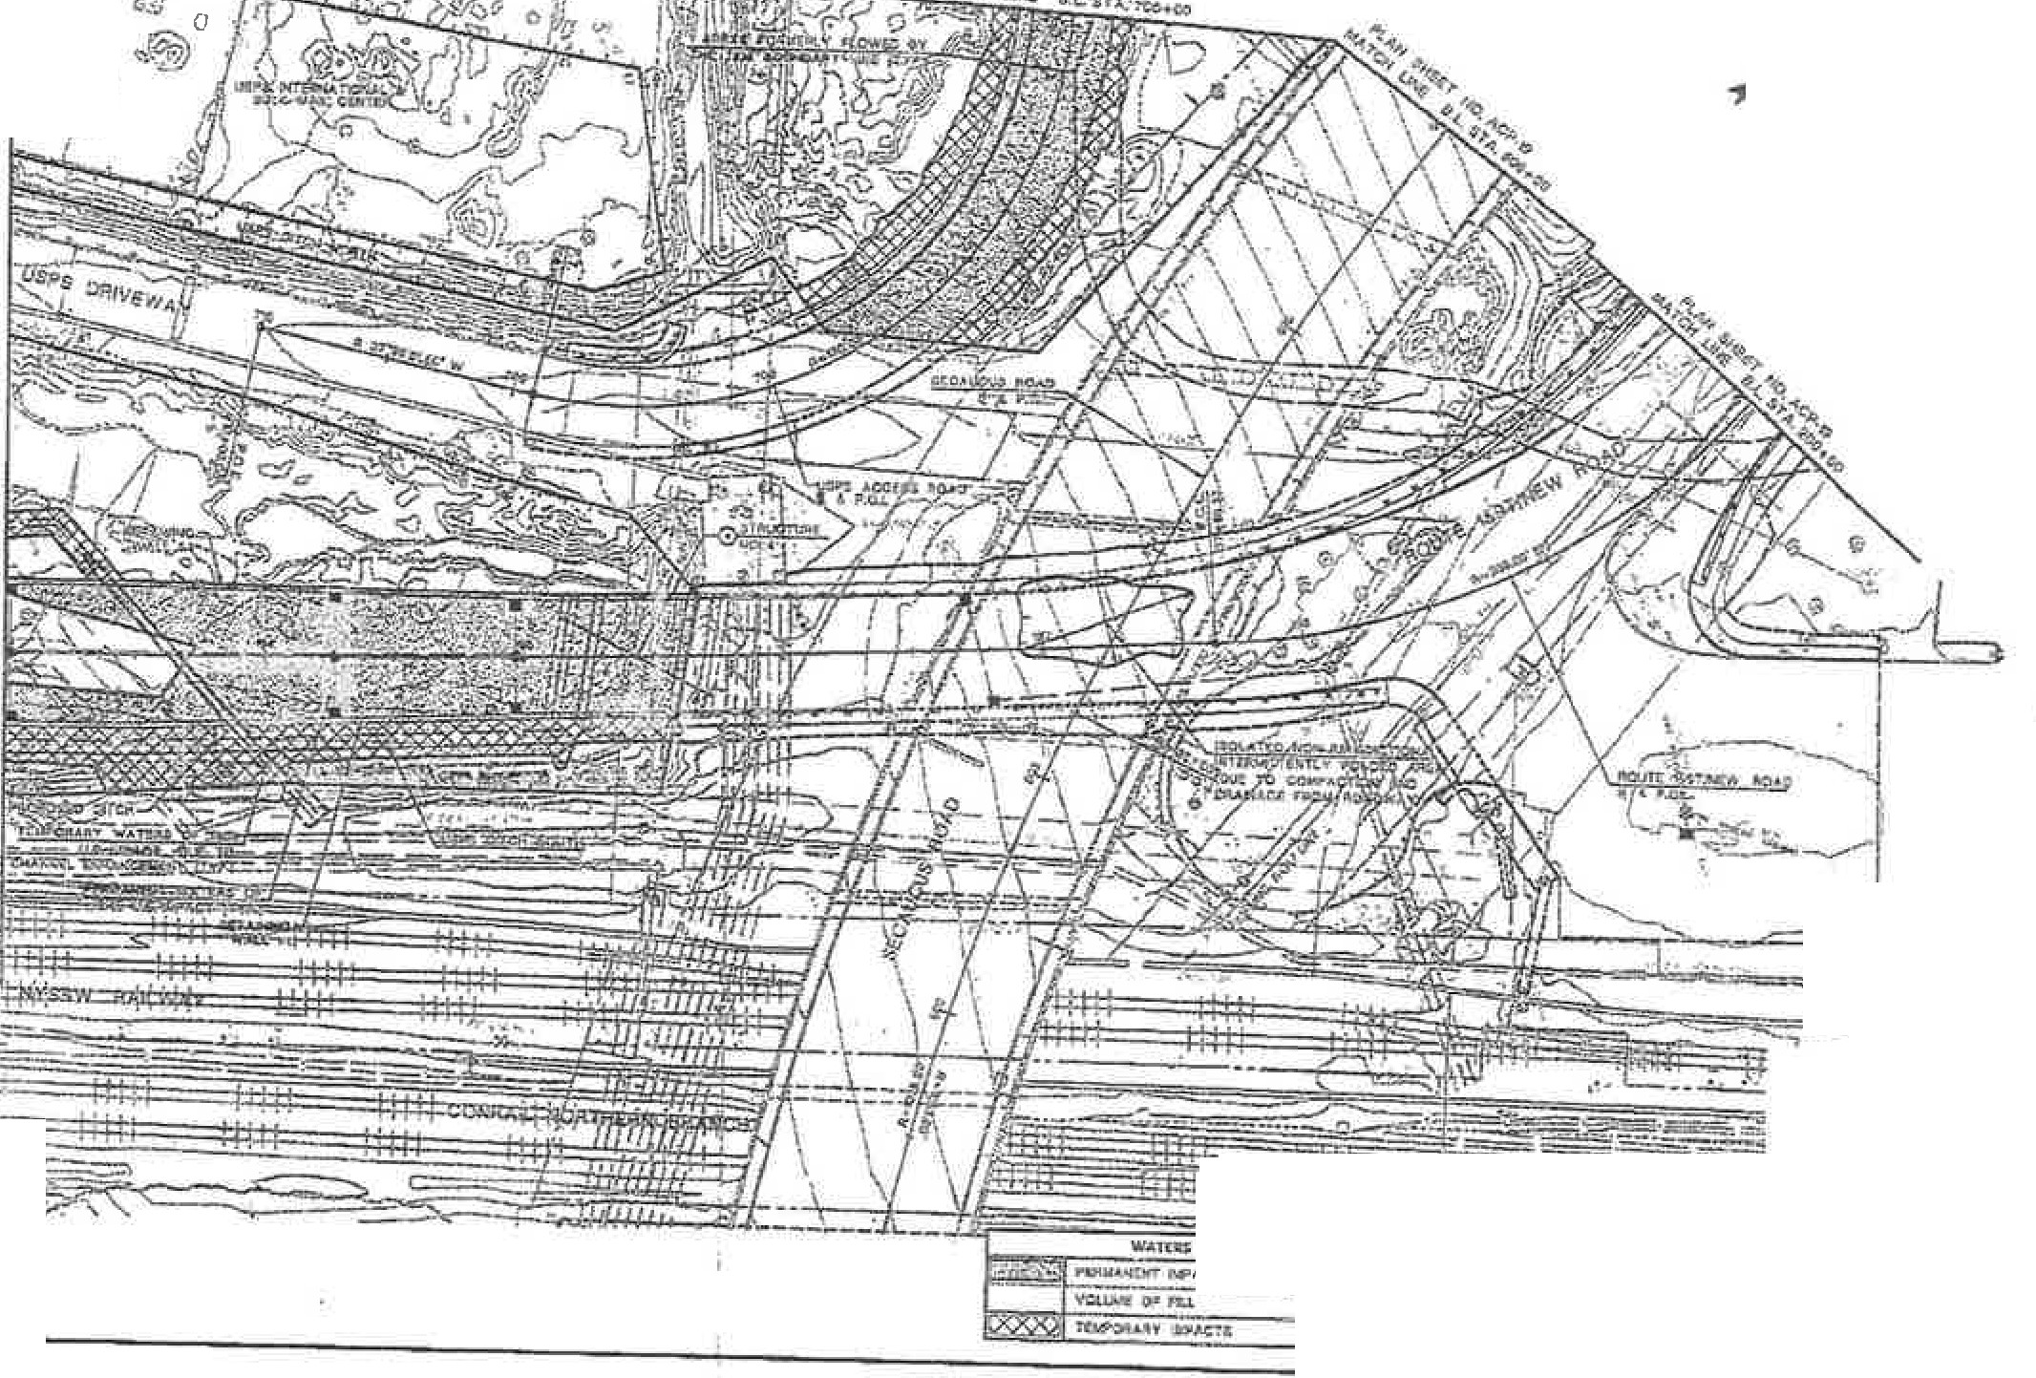CITY' OP JER81'Y ClT,Y COUNTY OF llUDSON

\ l
\ [
\1:::::;
/*

· _t t!
a, ,
I ._.I I
==:::j
- - 1 ---
-

1'rr:i -=-,-c;=
.---·- :- -/1=

w ,:,:-
HIW ltU.f't tlO.
-_c ,..

bw .sz ,RWLJll;,[ .11.
- =-
W-A"l'OG OJI IMC .nm i..w,a.m
ws-o;, 1=--cu
:Uc:f' U. C:,01:

Jiff•
.P-!OU... ,.ti

USACE PERMIT PLANS
U't O tr Jl,'t( fA.TID H
.=.xf'.11.l.
Q:OIJTI 1.&ftN'tw ROAD
C0h"TRACT$ l, J &. 3
-
...
wo-s.
co. CT 0 001uo 0, :a
DH\&&010 & IIOOlllt OU

1.1,lil " "' CJ

I 1,-iriQ l't.Al,l "f• ,
- Li _ I
@
il\ll, \)* :t.o

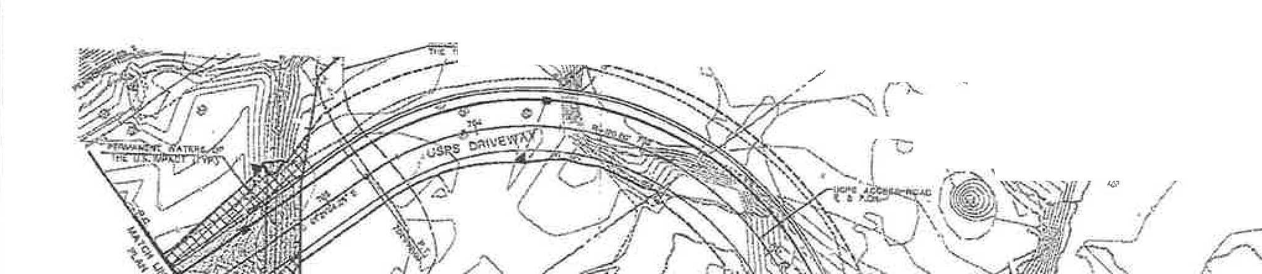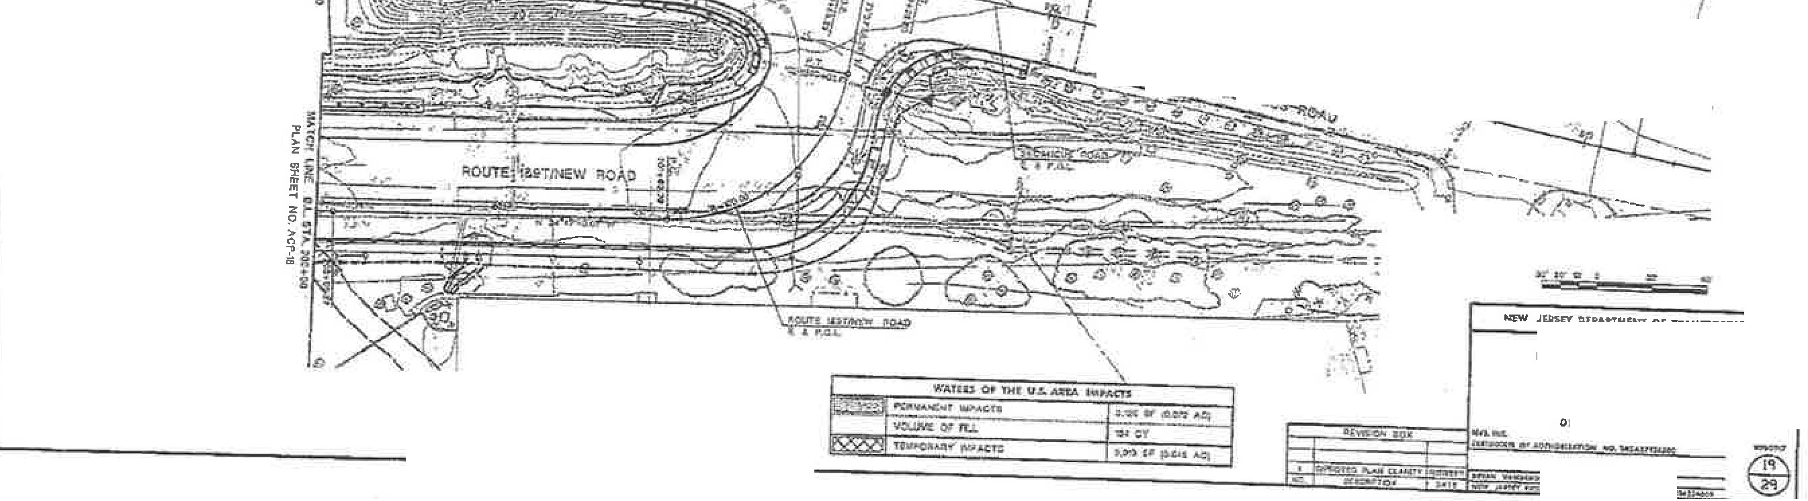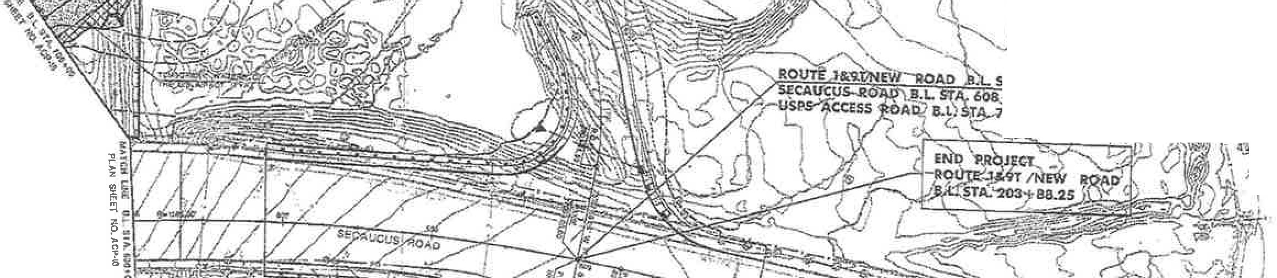USAGE FILE NUMBER: NAN-2017-01454
CITY OIi JllJlSEY cr;r COUNTY 0/1 HUDSON

..,,. ,..

->-(

·\

" " ' ,

.
\ ) \

-, --J_,,,-\^{L}
t--·\\
:L,s.;,l :,o::,c..•'1/

\\
'.
/4\ ,
4!/,/;'\-1

7/ z o ! - ..,,,,..,-"""'""-_ ,-,..- -- . . \ \.A'-.',k
- 7\
.\
'

C,\l

,. ,..
, - -
...: - ·" ... 'Lflfl

- '""'""""'->.,.._;;.·:...·-::.f.... . , .. - , ,.,. -s. -.:;·-;,o,- ·
- -, ' p .·· • . --

; lf§ -X5 ! - . JUIK'( tl.LPAttMIENT Of Tl IUIWCIRTAffON
USACE PERMIT PLANS
IWUfE )&91,NEW ltOAD
t ,
CO ,A(T ,S ..t.
CDNTRAa NOS. 000,u i:.oa ,
00 0, '40 10 • 000 1 U Q

...
C:,.5 \;f'<L -2..:o { '.;}.6

STATE OF NEW JERSEY DEPARTMENT OF ENVIRONMENTAL PROTECTION
DMSION OF LAND USE REGULATION
Mail Code 501-02A, P.O. Box 420, Trenton, New Jersey 08625-0420
Telephone: (609) 777-0454 or Fax: (609) 777 3656
www.nj.gov/DEP/Landusc

In acco1rl!!fice with Vi l!lws, l_lfld 1-egul ons of t!t Slate QfN w .Je1rey, U1c Dt.'{)aCtment of Envimnmentnl Protection hereby grantsti$.perm!! t pcrf '/11the activities desoilx:d below. Thispennit is1evocablewi01due cause and is subje<; \0. d1'l lli1_ 1i!ll1ions., terms and ooqditioos llliied low Md on tlie auached pages. For tl1e  ptt!J)OSC Of this: »J,f'perrJ,i[f' ' nJean5 1'upproviiJ, a:ttifiratiO , regislratiOJl, atJthorizaliOll, WalVCJ, Ctc,"  Vi9lntion of a_ny feim_,condil/011 or_linula!ioo ,of1his pennit (s. oli!llon of the implementing rules and may  subjcctthe pennittec toenfurcement action. : . . . |  |  | Approval Dat  i-EB O 6 2018
Expiration Date
FEB D 5 2023
Permit Numbel'(s): | Type of Approval(s):  HMC Water Quality Ce11ificate Flood Hazard Area Individual Permit |  | Enabling Statute(s):
0906-15-0010.1 CDT170001  0906-15-0010.1 FHA170001 |  |  | NJSA 12:5-3 et seq. WFD; NJSA 58:16A et seq. FHACA;  NJSA 58:I0A-1 et seq. WPCA;
 |  |  | NJSA 58:I tA-1 et seq. WQPA;
Permittee:  New Jersey Depattment of Transportation Amber Cheney  1035 Parkway Ave  Trenton, NJ 08625 •., |  | Site Location:  Block(s) & Lot(s): [NIA, NIA] Municipality: Jersey City County: H:udson  ·.1  . '
.
Description of Authorized Activ_ities: '· ·· ,
The construction of Route 1&9 New Road, extending from St. Paul's Avenue to Secaucus Road, in Jersey City, Hudson County within the New Jersey Hackensack Meadowlands District. The activities 11lso include but are not limited to the replacement of two bridge structures passing over the. NJ.Transit M&E Line and the NJ Transit Wye Tracks, a new viaduct structure to carry Route 1&9 New Road over the NJ Transit Mainline and No,rfolk Southem's Croxton Yard; a riew bridge structure over the tenninus of the Unnamed tributary to Penhorn Creek 2, the relocation of the United States Post l Service(USPS) Ditch South, the construction of three stormwater manageme lt basins, ret.ain.ing walls to SUp})OIJthe new road, in1proy ts to· w e.sr $ide_Road,County Road and Secaucus A venue, and the relo at.i·on_ of xWirig utility lines. · • ·. · ' • · · · ·. .. • '
, ..
This project will.result in the pe1manent impacts ofl.578 acres of freshwater w.etlan_ds and 0,624 Jlc!'esof open water ditches to construct the Route1&9/New Roaq and for the relocation USPS bitch South. Additionally, 1.501 acres 9f wetlands and 1.130 acres
of open water ditches will b te1J1porarily impacted to construct the Route I ( New_ R_o_ad and will b_e restoi:edfollowing completion of
the project. : ··. _ •-· ·.· , :·: ·.·. · .. ": , : : · · : .. ·.':·· ....· ;-
: ' . . ...
This permit is aut or ed_ 1-1nder and in compliance with the Rules on Coasta!Zone Management; N.J.A.C. 7:7-l.1 et seq., as
amended through June 20, 20t6, and Flood Hazard Area Rules, 7:13-1.1 et seq., as a!}l!)nded through December 18, 2017. By issuance of this pennit, the State oO{ew Jersey does not relinquish tidelands o nfar I!lp 9-r . Jahn,_ o. any, portion of the subject property or
adjacent properties . : .. . . .. · • ·. · · ... · · · · :
Pr•"71ZLI . . ' ' ·, \ '  '.· ..·. . ..,  Matthew Resnick ·. ., '. .  .. •• ·1  •: .. ..  If the permittee undertakes any regulated activity authorized under a permit, such action shall constitute the permittee's acceptance of the permit in its entirety as well as the pe1mittee's agreement to abide by the permit and all conditions therein. |  |  |  | Received and/or Recorded by
 |  |  |  | County Clerk:
This permit is notvalid unless authorizing signatu1-e appears on thelast page.

SPECIAL CONDITIONS FOR A FLOOD HAZARD PERMIT:
  - Material Disposal: All excavated material and dredge material shall be disposed of in a lawfitl manner. The material shall be placed outside of any flood hazard area, riparian zone, regulated water, freshwater/coastal wetlands and adjacent transition area, and in such a way as to not inte1fere with the positive drainage of the receiving area.

  - AH sediment barriers and other soil erosion control measures shall be installed prior to commencing any clearing, grading or construction onsite, and shall be maintained in proper working condition throughout the entire duration of the project.

  - Construction may only be performed in the dry or de-watered conditions. No work may be performed in the wet.

  - Construction equipment shall not be stored, staged or driven within auy channel, freshwater wetland or transition area, unless expressly approved by this permit and/or described on the approved plans.

  - Any new, reconstructed, enlarged, or elevated structure within a flood hazard area shall be secured to resist flotation, collapse, and displacement due to hydrostatic and hydrodynamic forces from floodwaters.

  - In order to protect anadromous fish within Penhom Creek, Penhom Creek unnamed tributaries l and 2, and the USPS Ditches North and South, no grading, construction or clearing is permitted within any watercourse onsite between March 1st through June 3ott• of any calendar year. Futthermore, any activity outside a watercourse, which would likely introduce sediment into the watercourse and/or increase its turbidity, is also prohibited during this period. The Depaitment reserves the right to suspend all regulated activities onsite should it be determined that the applicant has not taken proper precautions to ensure continuous compliance with this condition. If in-water sediment control measures are installed prior to the timing restrictions stated above, construction within the sediment control measures may proceed during the restricted period(s

  - De-watering of cofferdams must include properly sized temporaty sediment basins or other filtering methods to reduce turbidity. The stream area to receive return water discharged from cofferdams must be encompassed by a turbidity ba1Tier.

  - The regulated activity shall not expose unset or raw cement to flowing water within any channel or regulated water dul'ing constrnction.

  - Vegetation within 150 feet of the top of the bank shall only be disturbed in the areas specifically shown on the approved drawing/s. No other vegetation within 50 feet of the top of any stream bank onsite shall he disturbed for any reason. This condition applies to all channels onsite regardless of the contributory drainage area.

  - The Department has determined that this project meets the requirements of the Stonnwater Management rules at N.J.A.C. 7:8. Any future expansion or alteration of the approved stormwater management system, which would affect water quality, increase the rate or volume of stormwater leaving the site, or affect the infiltration capacity on the site, shall be reviewed and approved by the Department prior to construction. This includes any proposed changes to the discharge characteristics of any basin, the construction of new inlets or pipes that tie into the storm sewer netw?rk and/or the replacement of existing inlets or pipes with structures of different capacity.

  - The permittee shall make specific arrangements to ensure the continuous maintenance and efficient operation of all prnposed stormwater management measures onsite. This includes the inspection (and cleaning where necessary) of any and all constrncted swales, basins, and inlets devices at least four times per year and after every major storm totaling 1 inch ofrainfall or more, the inspection and cleaning of all mechanical treatment devices in accordance with their ce1tification letters (downloadable at\\ vw.njstorrm ate r.org/tr eatm nt.html), the use of appropriate soil conservation practices onsite, and any other reasonable effort required to maintain the stonnwater management system in good working order.

  - The proposed roadway will not be constructed above the flood hazard elevation. As such, it will be ove1topped by floodwaters and become inaccessible to emergency vehicles or other vehicular traffic during larger flood events. The Depattment of Environmental Protection shall not be held responsible for any prope1ty damage, safety risk or inconvenience that may result from such flooding.

  - The hydrologic and hydraulic analysis used for this permit shall not be used to obtain a flood hazard area verification for any prope1ties located within the watershed covered by this pennit. Should a verification be sought for any purpose in the future, new hydrologic and hydraulic analyses shall be required.

  - This permit does not pennit the stockpiling of any hazardous material. Should such material require stockpiling, the applicant shall obtain another permit from the Division of Land Use Regulation prior to stockpiling.

PROVISIONS OF THE HACKENSACK MEADOWLANDS WATER QUALITY CERTIFICATE:

- The authorized activity involves the permanent impacts of 1.578 acres of freshwater wetlands and 0.624 acres of open water ditches to construction the Route 1&9 New Road and relocate the USPS Ditch South. Additionally, 1.501 acres of wetlands and 1.130 acres of open water ditches will be temporarily impacted to construct the Route 1&9/New Road. All work is located entirely within the Hackensack Meadowlands District area. These disturbances would meet the requirements of the Freshwater Wetlands Protection Act Rules for an Individual Pennit. Therefore, a Water Quality Certificate will be issued for these activities.

- For any excavated area in freshwater wetlands and/or State open waters, the excavation shall be backfilled to the preexisting elevation, the uppermost 18 inches of the excavation shall be backfilled with the original topsoil material if feasible, the area above the excavation shall be replanted, in accordance with applicable BMPs, with indigenous wetlands species.

- Any pipes laid through wetlands, transition arflas, or State open waters shall be properly sealed so as to prevent leaking or infiltration, designed so as not to form a path for groundwater to be dischatged or drained from the wetland, and shall be placed entirely beneath the pre-existing ground elevation unless the applicant shows that placing some or all of the pipe above ground would be more environmentally beneficial.

STATE HISTORIC PRESERVATION OFFICE SPECIAL CONDITIONS:

  - Prior to project implementation, the permittee shall ensure that effects to historic and archaeological resources shal l be resolved through cons ul tation between the New Jersey Historic Preservation Office; the Federal Highway Administration as the lead Federal agency; any consulting pa1ties, and the permittee pursuant to Section I 06 of the National Historic Preservation Act and its implementing regulations at 36 CFR §800. Upon compl e tion of Section 106
Con sultation , the permittee shall provide the Division of Land Use Regulation a copy of Section 106 comments together with a statement of how the comments have been incorporated into the project, pursuant to N.J.A.C. 7:7A-19.S(u).

- If project circumstances change so that consultation under Section 106 of the National Historic Preservation Act is no longer necessary, the permittee shall cons ul t with the Division of Land Use Regulation and the New Jersey Historic Preservation Office to ensure the provisions ofN.J.A.C. 7:7A-5.7(b)( S) are met, prior to project implementation.

- For any hi storic and archaeological resources identified within the project site that are not subject to review pursuant to Section 106, the permittee shall consult with the Division of Land Use Regulation and the New Jersey Historic Preservation Office to ensure that the provisions of
N.J.A.C. 7:7A-5.7(b)(S) are met, prior to project i mp lementation.

- The pennittee shall ensure that all phases of archaeological survey and reporting shall meet with the Secretar y of the Interior'.\'Standards and Guidelines for Archaeology and Historic
Pres ervation, 1983 and the archaeological survey and repoiting rules at N.J.A.C. 7:4-8.4 through
8.5. Evaluations to determine the National Register eligibility of archaeological sites must be in keeping with the National Park Service's 2000 National Register Bulletin, Guidelinesfor Evaluating and Regist ering ArcheologicalProperlies. The individual(s) conducting the work will need to meet the relevant Secretary of the Interior's Professional Quali fications Standards for archaeology and historic architecture (48 FR 44738-9).

- Architectural survey must be in keeping with the Office's 1999 Guidelines for Architectural Su111ey (http:// www .ni.gov/dep/hpo/ I ide111ify/sur varcht.hl111) with reporting conforming to the rules at N.J.A.C. 7:4-8.6. Evaluations to de termine the National Register eligibility of historic properties must be in keeping with the National Park Service's National Register Bulletin, How to Appl y the National Register Criteria for Evaluation. Recommendations for avoidance of impacts to h istoric prope1ties must conform to The Secretaiy of the Interior's Standardsfor the Treatment ofHistoric Properti es.

FRESHWATER WETLAND MlTIGATIONPERMlT CONDITIONS:

I. The perm ittee shall mitigate for the temporary disturbance of 2.631 acre of emergent wetlands and the permanent loss of 2.202 acres of emergent wetlands through an on-site or off-site creation,
DOT purchased 2 5 restoration or enhancement project or with the purchase of credits from a mitigation bank serving credits from MRl3. the appropriate watershed management area in accordance witb the mitigation hierarchy. ( .J.A.C. 7:7A-1 l et seq). Addit io na lly , the permittee shall submit a restoration plan for areas oftempora1y
disturbance to the Mitigation Unit for review and approval. The restoration plan shall consist of native vegetation and depict all seed mixes to be used within the temporarily impacted wetlands.

- At least 90 days prior to the initiation of regulated activities authorized by this permit, the permittee shall submit a mitigation proposal to the Divis ion of Land Use Regulation (Division) for

review and approval. Activities authodzed by this permit shall not begin until the permittee has obtained written approval of a mitigation plan from the Department (N.J.A.C. 7:7A-l l.6(a)).

- All mitigation shall be conducted prior to or concurrent with the construction of the approved p1·oject (N.J.A.C. 7:7A-11.3(a)). Concmrent means that at any given time, the mitigation must track at the sm'ne or greater percentage of completion as the project as a whole.

- Jf the permittee fails to perform mitigation within the applicable time period the acreage of mitigation required shall be increased by 20 percent each year after the date mitigation was to begin (N.J.A.C. 7:7A-11.3(c)).

- If the applicant is considering obtaining land to satisfy a mitigation requirement, the Depa1tment strongly recommends that the permittee obtain the Division's conceptual review and approval of any land being considered as a potential mitigation area.

- If the permittee is purchasing credits from a mitigation bank to satisfy a mitigation requirement, prior to the initiation of regulated activities authorized by this permit, the permittee shall submit proof of purchase for 2.202_of mitigation credits from an approved wetland mitigation bank to the attention of the Mitigation Unit Supervisor, NJDEP, Division of Land Use Regulation at Mail Code 501-02A, P.O. Box 420, Trenton, NJ 08625-0420.

At this time, the following bank(s) are approved to serve the project area; additional banks may be approved at any time, so please contact the Mitigation Unit for the most up to date service area information if you would like additional options.

Kane Wetland Mitigation Bank-Andrew Derickson, (303) 521-085lor at ad - rick on(ri)cfg­
bp.com

MRI 3 Mitigation Bank- Contact Mark Renna of Evergreen Environmental, LLC at 973- 305-0643 or 973-356-7164 or at mrenn a@eve rgree nenv.com

- If the permitte e is considering conducting a creation, restoration or enhancement project, the following conditions shall apply:

  - Prior to the initiation of regulated activities authorized by this permit the permittee shall submit a final design of the mitigation project for approval and include all of the items listed on the checklist entitled .Check lis l for om le te nes : ' rea t ion . Re !ora t ion or En hanceme nt fo r a Fres hw ater Wetla nd Mitigation Proposa l located at htt p://www.nj .gov/dep/Ianduse/fo nn s/index.html.

  - Prior to the completion of the mitigation project, the permittee shall complete, sign ancl file with the County Clerk (the Registrar of Deeds and Motigages in some counties), a conservation restriction that meets the requirements of N.J.A.C. 7:7A-1 2. l. The conservation restriction shall include the wetland and required transition area and conform to the format and content of the Wetlands Mitigation Area model conservation restriction that is available at: J1ttp://www.ni.gov/dep/l11nduse/ forms/in dex. ht111I. The applicant is required to include a metes and bounds description shown on a map . Within 180 days of the issuance of the mitigation approval, the recorded conservation restriction shall be provided to the Mitigation Unit, NJDEP Division of Land Use Regulation for verification. (N.J.A.C. 7:7A-12.l et. seq.)

c . The pennittee shall notify the Mitigation Unit at the Division of Land Use Regulation in writing at least 30 days ptfor to the start of constn,ction of the wetland mitigation project to arrange an on-site pre-construction meeting among the permittee, the contractor, the consultant and the Division.

d. To ens ure the intent of the mitig ation design and its predic ted wetland hydrology is realized in the landscape, the mitigation designer shall be present on-site during all critical stages of mitigation construction and during the restoration of any temporarily impacted areas. Critical stages of consh·uction include but are not limited to herbicide applicat io ns, ea1thmoving activities, planting, and inspect ions .

e, The permittee shall be responsible for ensuring that best management practices are used tJuoughout construction to control the spread and colonization of highly invasive plants. Specifically, all equipment, especially tracks and tires, must be thoroughly cleaned evety time equipment or vehicles move from an area containing invasive plants or from off-site to the mitigation area. In addition, soil containing root fragments and above-ground vegetative material from invasive plants shall be carefully managed during ea1thmoving activities and disposed of at a suitable off site location rather than mulched and reused or stockpiled elsewhere on the site. For information on the specific species that are considered to be invas ive , please refer to the Invasive Plant Atlas at http: //\\'W\\ .inv a iveplantatlas.org/index. ht ml.

- If changes to the mitigation design are necessary to ensure success of the project as a result of on-site conditions, the mitigation designer shall immediately notify the Division in writing and submit an alternative plan which achieves the proposed wetland conditions. The Division shall review the plan in accordance with N.J.A .C. 7:7A-11.7 . Any modifications to the plan that are reviewed and approved by the Division must be shown on a signed and sealed revised plan. The As-Built plans required as a patt of the Constrnction Completion Report may serve as the signed and sealed revised plan required to be submitted as part of the construction modification process described above if time constraints warrant such action and have been approved by the Division in writing .

- Within 30 days of final grading of the mitigation site and prior to planting, the permittee shall notify the Mitigation Unit at the Division of Land Use Regulation in writing to arrange a post-grading construction meeting among the permittee, contractor, consultant and the Div is ion.

- Within 60 days following the final planting of the mitigation project, the permittee shall submit a Construction Completion Report to the Division detailing as-built conditions (see
below) and any changes to the approved mitigation plan that were made during construction (N.J.A.C. 7:7A-l I . 12 et. seq.). The Construction Completion Report shall contain, at a minimum, the following information:

  - A completed W omp !et io n of Construc tio n Fo rm. This
form is located d usc/ forms /indcx.html and ce11ifies that the mitigation project has been constructed as designed and that the proposed area of wetland creation, restoration or enhancement has been accomplished;

11. As-Built plans which depict final grade elevations at one foot contours and include a table of the species and quantities of vegetation that were planted including any grasses that may have been used for soil stabilization purposes; and

111. Photos of the constructed wetland mitigation project with a photo location map as well as the GPS waypoints in NJ state plane coordinates NAD 1983.

1. Within 30 days following final planting of the mitigation project, the permittee shall post the mitigation area with pennanent signs which identify the site as a wetland mitigation project and that all-teffain vehicle use, motorbike use, mowing, dumping, draining, cutting and/or removal of plant materials is prohibited and that violators shall be prosecuted and fined to the fullest extent under the law. The signs must also state the name of the permittee, a contact name and phone number, and the Department's permit number.

J. The permittee shall monitor all freshwater wetland and transition area projects for a minimum of 5 years, unless otherwise stipulated within the approved mitigation proposal, beginning the first full growing season after the mitigation project has been completed. The permittee shall submit monitoring reports to the Division of Land Use Regulation no later than December 3 P¹ of each full monitoring year (N.J.A.C. 7:7A-11.12(g)). All monitoring rep011s must include the 'standard items identified in the checklist entitled, "Wetland Mitigation Monitoring Project Checklist", which can be found at b!!p://www.n j.go v/de p/ la ndu se/fo rms/ind ex. htmI.

k. Once the required monitoring period has expired and the permittee has submitted the final monitoring rep011, the Division will make the finding that the mitigation project is either a success or a failure. This mitigation project wilJ be considered successful if the permittee demonstrates all of the following:

1. That the goals of the wetland mitigation project, including acreage and the required transition area, as stated in the approved wetland mitigation proposal and the permit have been satis fied. The permittee shall submit a field wetland delineation of the wetland mitigation project based on the Federal Manual for Identifying and Delineating Jurisdictional Wetlands (1989) which shows the exact acreage of State open waters, emergent, scrub/shrub and/or forested wetlands in the mitigation area;

    - The site has an 85 percent survival and 85 percent area coverage of the mitigation plantings or target hydrophytes, which are species native to the area and similar to ones identified on the mitigation planting plan. All plant species in the mitigation area must be healthy and thriving and all trees must be at least five feet in height;

    - The site has less than IO percent coverage by invasive 01· noxious species.

    - The site contains hydric soils or there is evidence of reduction occurring in the soil; and,

    - The proposed hydrologic regime as specified in the mitigation proposal has been satisfied.

1. The permittee is responsible for assuming all liability for any corrective work necessary to meet the success criteria established above (N.J.A.C. 7:7A-1 l.12(i)). The Division will notify the permittee in writing if the mitigation project is considered to be a failure. Within 30 days of notification, the permittee shall submit a revised mitigation plan to meet the success criteria identified above for Division review and approve I. The financial surety, if required, will not be

released by the Division until such time that the pennittee satisfies the success criteria as stipulated above.

RIP ARIAN ZONE MITIGATION CONDITIONS:
- Within 60 days of the issuance of this permit, the pennittee shall submit a proposal to mitigate for the temporary disturbance of 1.37 acres of herbaceous riparian vegetation as well as th,e pennanent loss of 0.247 acres of forested and 2.183 acres herbaceous riparian zone vegetation. The proposal shall be designed in accordance with the standards at N.. A.C. 7:13-13. Activities authorized by this permit shall not begin until the permittee has obtained written apprnval of a mitigation plan from the Depattment (N.J.A.C. 7:13-13.2(6)). Additionally, the permitee shall submit a restoration plan for areas of temporary disturbance to the Mitigation Unit for review and approval. The restoration plan shall consist of native vegetation and depict all seed mixes to be used within the temporarily impacted wetlands and invasive species control measures. The permittee shall continue to consult with the Mitigation Unit in order to design an approvable restoration plan for both temporary and permanent impacts to riparian zone vegetation.

- All mitigation shall be conducted prior to or concurrent with the regulated activity that causes the disturbance. (N.J.A.C. 7:13-13.3(a)l). Concmrnnt means that at any given time, the mitigation must track at the same or greater percentage of completion as the project as a whole.
As of the date of this perm it, there are no mitigation banks serving your project area. Additional banks may be approved at any time, so please contact the Mitigation Unit for the most up to date service area information if you would like additional options.

- Prior to the initiation of regulated activities authorized by this permit, the pe1mittee shall sign a Depa1tment approved conservation restriction to protect the mitigation area from future development that would remove the vegetation planted. (N.J.A.C. 7:13-13.2(g)). The conservation restriction shall conform to the format and content of the rules at N.J.A.C. 7:13-14 and the Riparian Zone Mitigation Area model located at http://www.nj.gov/dep/landuse/forms/index.html. The restl'iction shall be included on the deed and recol'ded in the office of the County Clerk (the Registrar of Deeds and M01tgages in some counties) in the county wherein the lands of the mitigation project are located. A metes and bounds description shown on a map must be included within the recorded conservation restriction. Within 10 days of filing the conservation restriction, the permittee must send a copy of the conservation restriction to the attention of the Mitigation Unit Supervisor, NJDEP, Division of Land Use Regulation at Mail Code 501-02A, P.O. Box 420, Trenton, NJ 08625-0420.

- The permittee shaJl monitor the riparian project for at least 5 years beginning the year after the riparian zone mitigation project has been completed (N.J.A.C. 7:13-13.12(c)). The permittee shall submit monitodng reports to the Division of Land Use Regulation, no later than December 31st of each full monitoring year.

  - All monitoring repotts except the final one should include the requirements and goals of the mitigation proposal and a detailed explanation of the ways in which the mitigation has or has not achieved progress toward those goals. If mitigation has not achieved progress, the report shall also include a list of corrective actions to be implemented and a timeline for completion.

  - The final monitoring report must include documentation an data demonstrating that:

    - The goals of the riparian zone mitigation as stated in the approved riparian zone mitigation proposal and the permit conditions have been satisfied.

    - At least 85 percent of the mitigation plantings have survived and that at least 85 percent of the mitigation area is established with native species similar to ones identified on the mitigation planting plan. All plant species in the mitigation area must be healthy and thriving. All trees must be at least 5 feet in height; and

    - The site is less than IO percent occupied by invasive or noxious species; and

    - The conservation restriction for the mitigation site has been executed and recorded.

- If the riparian mitigation project does not meet the success criteria established above the project shall be considered a failure and the permittee shall submit a revised riparian mitigation plan. The revised plan shall be submitted within 60 days of receipt of notification from the Division indicating the riparian mitigation project was a failure.

- If the Division detennines that the riparian zone mitigation project is not constructed in conformance with the approved plan, the permittee will be notified in writing by the Depa1tment and will have 60 days to submit a proposal to indicate how the project will be corrected.

STANDARD CONDITIONS:

I. The issuance of a permit shall in no way expose the State of New Jersey or the Depaiiment to liability for the sufficiency or c01Tectness of the design of any construction or structure(s). Neither the State nor the Department shall, in any way, be liable for any loss of life or property that may occur by virtue of the activity or project conducted as authorized under a permit.

- The issuance of a permit does not convey any propetty rights or any exclusive privilege.

- The permittee shall obtain all applicable Federal, State, and local approvals prior to commencement of regulated activities authorized under a permit.

- A petmittee conducting an activity involving soil disturbance, the creation of drainage structures, or changes in natural contours shall obtain any required approvals from the Soil Conservation District having jurisdiction over the site.

- The permittee shall take all reasonable steps to prevent, minimize, or correct any adverse impact on the environment resulting from activities conducted pursuant to the permit, or from noncompliance with the pe11nit.

- The permittee shall immediately inform the Depaitment by telephone at (877) 927-6337 (Warn DEP Hotline) of any noncompliance that may endanger the public health, safety, and welfare, or the environment. In addition, the pennittee shall inform the Division of Land Use Regulation by telephone at (609) 777-0454 of any other noncompliance within two working days of the time the permittee becomes aware of the noncompliance, and in writing within five working days of the time the permittee becomes aware of the noncompliance. Such notice shall not, however, serve as a defense to enforcement action if the project is found to be in violation of this chapter. The written notice shall include:
  - A description of the noncompliance and its cause;
  - The period of noncompliance, including exact dates and times;
  - If the noncompliance has not been corrected, the anticipated length of time it is expected to continue; and

  - The steps taken or planned to reduce, eliminate, and prevent recurrence of the noncompliance.

- It shall not be a defense for a permittee in an enforcement action that it would have been necessary to halt or reduce the authorized activity in order to maintain compliance with the conditions of the permit.

- The permiltee shall employ appropriate measures to minimize noise where necessary during construction, as specified inN.J.S.A.13:lG-1 et seq. and NJ.AC. 7:29.

- The issuance of a pennit does not relinquish the State's tidelands ownership or claim to any portion of the subject property or adjacent properties.

- The issuance of a permit does not relinquish public rights to access and use tidal waterways and their shores.

- The permittee shall allow an authorized representative of the Depattment, upon the presentation of credentials, to:
  - Enter upon the permittee's premises where a regulated activity is located or conducted, or where records must be kept under the conditions of the permit;
  - Have access to and copy, at reasonable times, any records that must be kept under the conditions of the pe1mit; and
  - Inspect at reasonable times any facilities, equipment, practices, or operations regulated or required under the permit. Failure to allow reasonable access under this paragraph shall be considered a violation of this chapter and subject the permittee to enforcement action under.

- The pennittee and its contractors and subcontractors shall comply with all conditions, site plans, and supporting documents approved by the permit. Any noncompliance with a permit constitutes a violation of this chapter and is grounds for enforcement action under, as well as, in the appropriate case, suspension and/or te1mination of the pennit.

- All conditions, site plans, and suppotting documents approved by a permit shall remain in full force and effect so long as the regulated activity or project, or any portion thereof, is in existence, unless the pe1mit is modified.

- For Coastal Permits, Flood Hazard Permits and Flood Hazard Verifications, and Freshwater Wetlands Permits, the permittee shall record the permit, including all conditions listed therein, with the Office of the County Clerk (the Registrar of Deeds and Mortgages, if applicable) of each county in which the site is located. The permit shall be recorded within 30 calendar days of receipt by the pennittee, unless the permit authorizes activities within two or more counties, in which case the permit shall be recorded within 90 calendar days of receipt. Upon completion of all recording, a copy of the recorded permit shall be fmwarded to the Division of Land Use Regulation at the address set fmth in the rules.

- Jfany condition or permit is determined to be legally unenforceable, modifications and additional conditions may be imposed by the Department as necessary to protect public health, safety, and welfare, or the environment.

- A copy of the permit and all approved site plans and suppo11ing documents shall be maintained at the site at all times and made available to Depat1ment representatives or their designated agents immediately upon request.

- A permit shall be transfen-ed to another person only in accordance with the regulations.

18 . A permit can be suspended or terminated by the Depa1tment for cause.

- The submittal of a request to modify a permit by the permittee, or a notification of planned changes or anticipated noncompliance, does not stay any condition of a permit.

- Where the permittee becomes aware that it failed to submit any relevant facts in an application, or submitted incorrect information in an application or in any repmt to the Department, it shall promptly submit such facts or information.

- The permittee shall submit written notification to the Bureau of Coastal and Land Use Compliance and Enforcement, 401 East State Street, 4th Floor, P.O. Box 420, Mail Code 401- 04C, Trenton, NJ 08625, at least three working days prior to the commencement of regulated activities.

- The permittee shall not cause or allow any unreasonable interference with the free flow of a regulated water by placing or dumping any materials, equipment, debris, or structures within or adjacent to the channel while the regulated activity(ies) is being undertaken. Upon completion of the regulated activity(ies), the permittee shall remove and dispose of in a lawful manner, all excess materials, debris, equipment, and silt fences and other tempora1y soil erosion and sediment control devices from all regulated areas.

- The regulated activity shall not destrny, jeopardize, or adversely modify a present or documented habitat for threatened or endangered species, and shall not jeopardize the continued existence of any local population of a threatened or endangered species.

APPROVED PLANS:

The drawings hereby approved are One hundred eighty two, (182) sheets prepared by the HNTB Corperation, dated and revised as noted below, entitled:

"NEW JERSEY DEPARTMENT OF TRANSPORATION, ROUTE 1&9T/NEW ROAD, CONSTRACTS 1, 2 & 3, CONTRACT NOS. 000188000, 000188010 & 000188020", dated September
20, 2017, revised as noted; .
  - FLOOD HAZARD AREA PLANS, sheet 1, drawing FHA-1, last revised December 12, 2017,
  - FLOOD HAZARD AREA PLANS, sheets 2 and 4 through 18, drawing FHA-2 through FHA-18, last revised November 14, 2017,
  - FLOOD HAZARD AREA PLANS, sheet 3, last revised January 12, 2018
  - USACE PERMIT PLANS, sheets l through 19, drawings ACP-1 through ACP-19,
  - CONSTRUCTION DETAILS, sheets I and 2, drawings CD-I, CD-2, last revised January 12, 2018,
  - CONSTRUCTION DETAILS, sheets 3, drawings CD-3,

"NEW JERSEY DEPARTMENT OF TRANSPORTATION, BUREAU OF STRUCTURAL ENGINEERING, ROUTE 1&9/NEW ROAD, ST. PAULS AVENUE TO SECAUCUS ROAD, CONTRACT NO. 000028042, CITY OF JERSEY CITY, COUNTY OF HUDSON," prepared by David
N. Murray of the HNTB Corporation, dated September 20, 2017"
- GENERAL PLAN & ELEVATION, sheet 1,
- GENERAL PLAN & ELEVATION, sheet 13;
"NEW JERSEY DEPARTMENT OF TRANSPORTATION, BUREAU OF STRUCTURAL ENGINEERING, ROUTE 1&9/NEW ROAD, ST. PAULS AVENUE TO SECAUCUS ROAD, CONTRACT NO. 00018800, CITY OF JERSEY CITY, COUNTY OF HUDSON," prepared by Richard
J. Schaefer, of the HNTB Corporation, dated September 20, 2019"
- GENERAL PLANS & ELEVATION 1, sheet B-30 ofB-71,
- GENERAL PLANS & ELEVATION 2, sheet B-31 of B-71,
- GENERAL PLANS & ELEVATION 3, sheet B-32 ofB-71,
- GENERAL PLANS & ELEVATION 4, sheet B-33 of B-71,
- GENERAL PLANS & ELEVATION 5, sheetB-34 ofB-71,
- GENERAL PLANS & ELEVATION 6, sheet B-35 ofB-71,
- GENERAL PLANS & ELEVATION 7, sheet B-36 ofB-71,
- GENERAL PLANS & ELEVATION 8, sheetB-37 ofB-71,
- GENERAL PLANS & ELEVATION 9, sheet B-38 ofB-71,
- GENERAL PLANS & ELEVATION 10, sheetB-39 ofB-71,
- GENERAL PLANS & ELEVATION 11, sheet B-40 of B-71,
- TYPICAL RETAINING WALL SECTIONS, sheet B-41 of B-7l
- GENERAL PLANS & ELEVATION 1, sheet B-42 ofB-71,
- GENERAL PLANS & ELEVATION 2, sheet B-43 ofB-71,
- GENERAL PLANS & ELEVATION 3, sheet B-44 of 8-71,
- GENERAL PLANS & ELEVATION 4, sheetB-45 ofB-71,
- GENERAL PLANS & ELEVATION 5, sheet B-46 of B-71,
- GENERAL PLANS &ELEVATION 6, sheet B-47 ofB-71,
- TYPICAL RETAINING WALL SECTIONS, sheetB-48 ofB-71

"STATE OF NEW JERSEY DEPARTMENT OF TRANSPORTATION, ROUTE 1&9/NEW ROAD, FROM COUNTY ROAD TO SECAUCUS ROAD CONTRACT #1, CONTRACT NO. 000188000"
- CONSTRUCTION PLANS, pages C-1 through C-10,
- DRAINAGE PLANS, pages D-1 through D- I 0,
- PROFILES, pages P-1 through P-8,
- CROSS SECTIONS, pages X-1 through X-65,

"STATE OF NEW JERSEY DEPARTMENT OF TRANSPORTATION, ROUTE 1&9/NEW ROAD, FROM COUNTY ROAD TO SECAUCUS ROAD CONTRACT #2, CONTRACT NO. 000028042"
- CONSTRUCTION PLANS, pages C-1 through C-5,
- DRAINAGE PLANS, pages D-1 through D-5
- PROFILES, pages P-1 through P-X
•
"STATE OF NEW JERSEY DEPART!vffiNT OF TRANSPORTATION, ROUTE 1&9/NEW ROAD,
FROM COUNTY ROAD TO SECAUCUS ROAD CONTRACT #3, CONTRACT NO. 000188020"
- CONSTRUCTION PLANS, pages C-1 through C-9,
- DRAINAGE PLANS, pages D-1 through D-9
- PROFILES, pages P-1 through P-X

fn accordance with N.J.A.C. 7:7A-21, any person who is aggrieved by this decision may request a hearing within 30 days of the date the decision is published in the DEP Bulletin by writing to: New Jersey Depa1iment of Environmental Protection, Office of Legal Affairs, Attention: Adjudicatory Hearing Requests, Mail Code 40 l- 04L, P.O. Box 402, 401 East State Street, 7i1i Floor, Trenton, NJ 08625-0402. This request must include a completed copy of the Administrative Hearing Request Checklist found at www.state.nj.us/dep/landuse/forms. Hearing requests received after 30 days of publication notice may be denied. The DEP Bulletin is available on the Depaiiment's website at www.state.nj.us/dep/bulletin. fn addition to your hearing request, you may file a request with the Office of Dispute Resolution to engage in alterna tive dis pute resolution. Please see the website www.nj.gov/dep/odr for more information on this process.

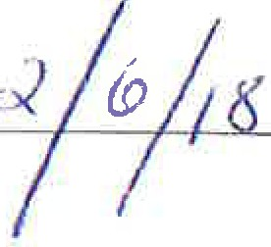
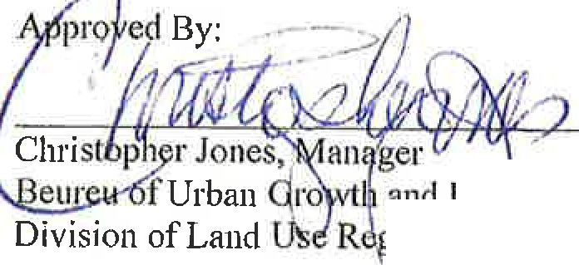If you need clarification on any section of this permit or conditi ons, please contact the Divi s ion of Land Use Regulation' s Technical Support Call Center at (609) 777-0454.

an Red elopme nt
. ilation

Date

Original sent to Agent to record
c: Pennittee Construction Official

